**Practical 1 : Download readymade free templates of E-Commerce websites and modify it**

**Step 1:Search on google nicepage.**

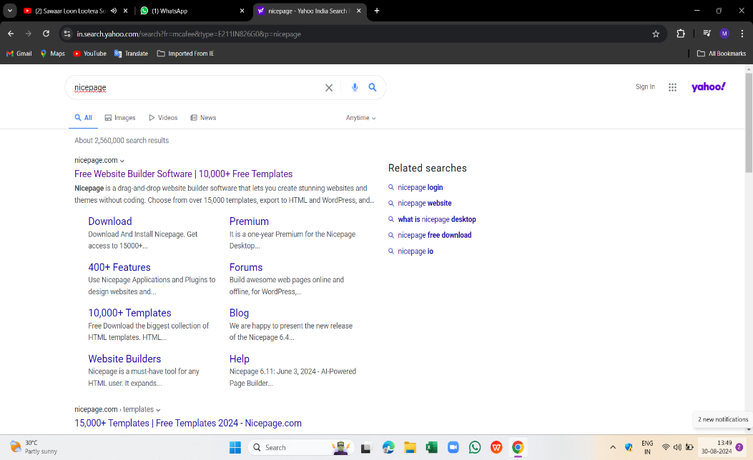

**Step 2:Click on download now**

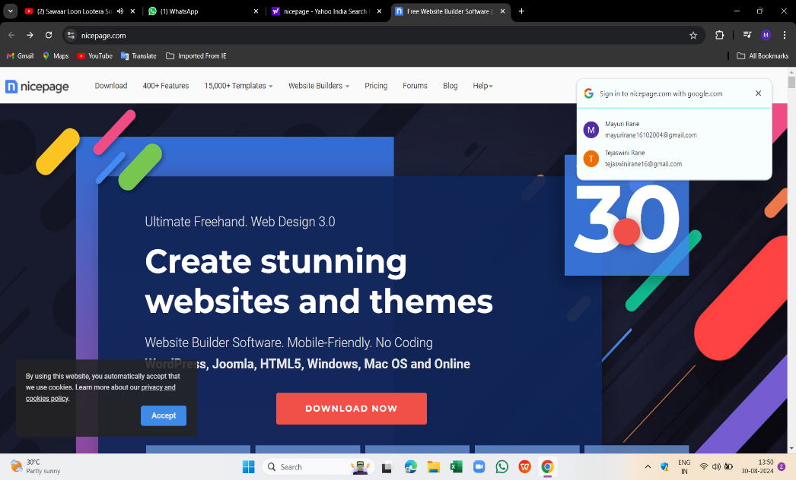

**Step3: Click on download windows app**

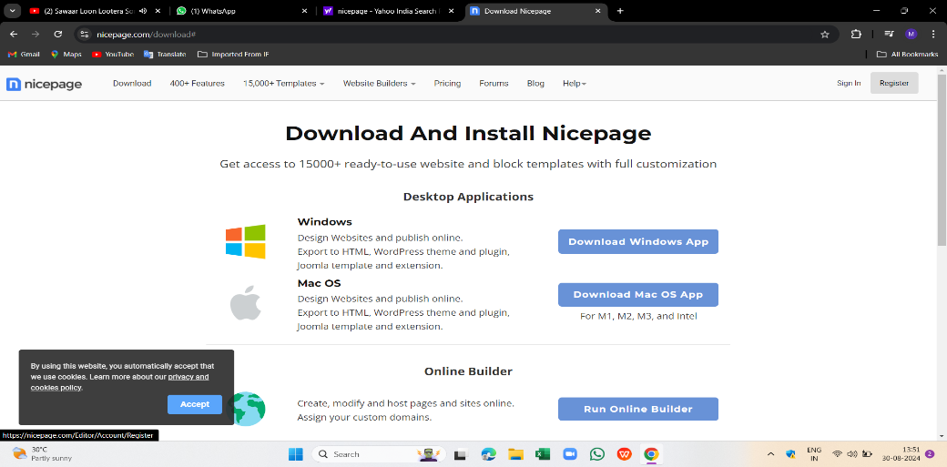

**Step 4: enter email or signup**

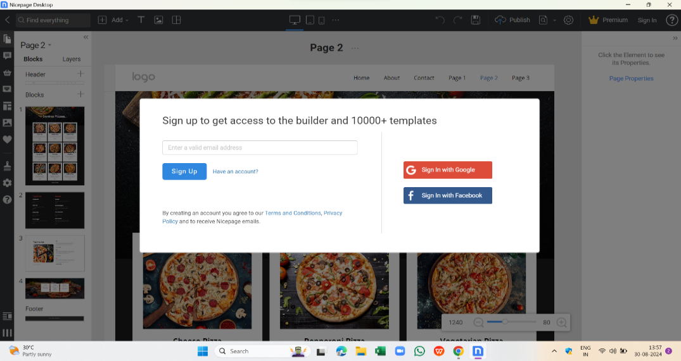

**Step 5: Press continue**

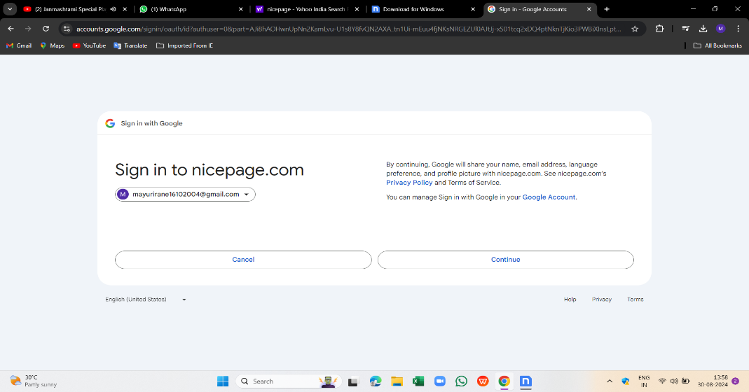

**Step 6:After open the nicepage , select new page or free readymade template**

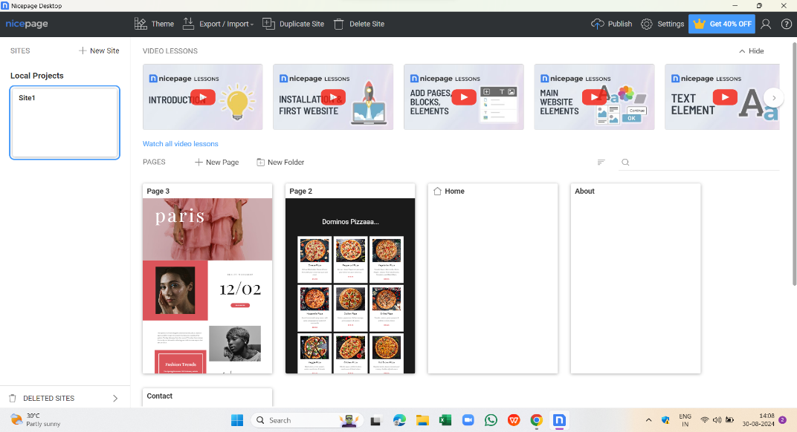

**Step 7:Here we can change any information of our choice**

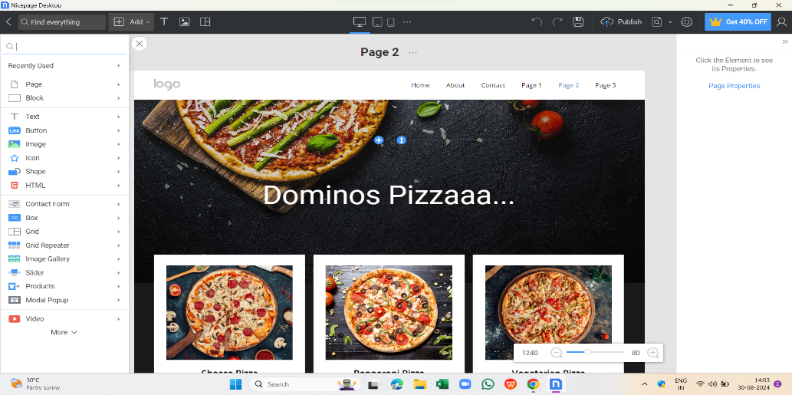

**Step 8:After creating template,we can publish it**

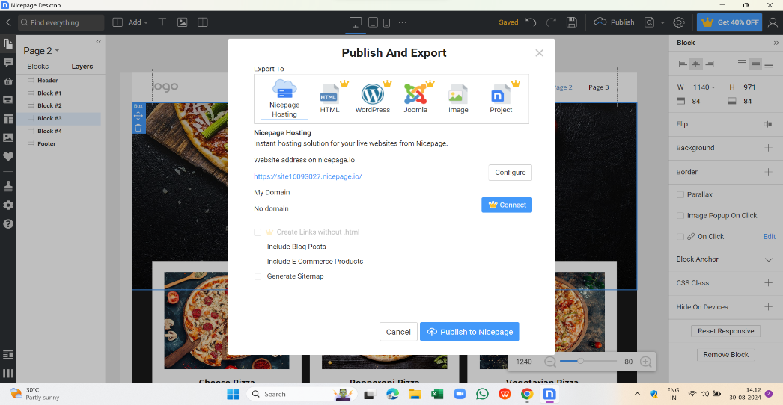

**Step 9: template will publish after the process**

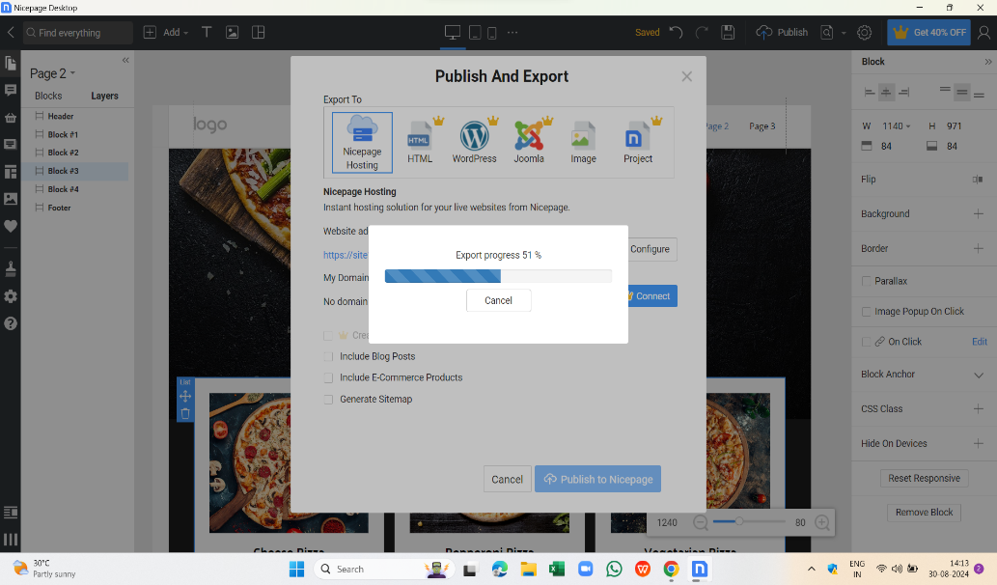

**Practical 2 : Create simple and static demo web page for online shopping site.**

**Html file:**

<!DOCTYPE html>

<html>

<head>

<title>Online Shopping Site</title>

<link rel="stylesheet" href="style.css">

</head>

<body>

<header>

<h1>Online Shopping Site</h1>

</header>

<nav>

<ul>

<li><a href="#">Home</a></li>

<li><a href="#">Products</a></li>

<li><a href="#">About Us</a></li>

<li><a href="#">Contact Us</a></li>

</ul>

</nav>

<main>

<h2>Featured Products</h2>

<section class="products">

<article>

<img src="product1.jpg" alt="Product 1">

<h3>Product 1</h3>

<p>Price: $19.99</p>

</article>

<article>

<img src="product2.jpg" alt="Product 2">

<h3>Product 2</h3>

<p>Price: $29.99</p>

</article>

<article>

<img src="product3.jpg" alt="Product 3">

<h3>Product 3</h3>

<p>Price: $39.99</p>

</article>

</section>

</main>

<footer>

<p>&copy; 2024 Online Shopping Site</p>

</footer>

</body>

</html>

**CSS (in style.css file):**

body {

font-family: Arial, sans-serif;

margin: 0;

padding: 0;

}

header {

background-color: #333;

color: #fff;

padding: 20px;

text-align: center;

}

nav ul {

list-style: none;

margin: 0;

padding: 0;

display: flex;

justify-content: space-between;

}

nav li {

margin-right: 20px;

}

nav a {

color: #333;

text-decoration: none;

}

main {

display: flex;

flex-direction: column;

align-items: center;

padding: 20px;

}

.products {

display: flex;

flex-wrap: wrap;

justify-content: center;

}

article {

margin: 20px;

padding: 20px;

border: 1px solid #ddd;

border-radius: 10px;

box-shadow: 0 0 10px rgba(0, 0, 0, 0.1);

}

article img {

width: 100%;

height: 150px;

object-fit: cover;

border-radius: 10px 10px 0 0;

}

footer {

background-color: #333;

color: #fff;

padding: 10px;

text-align: center;

clear: both;

}

Output:

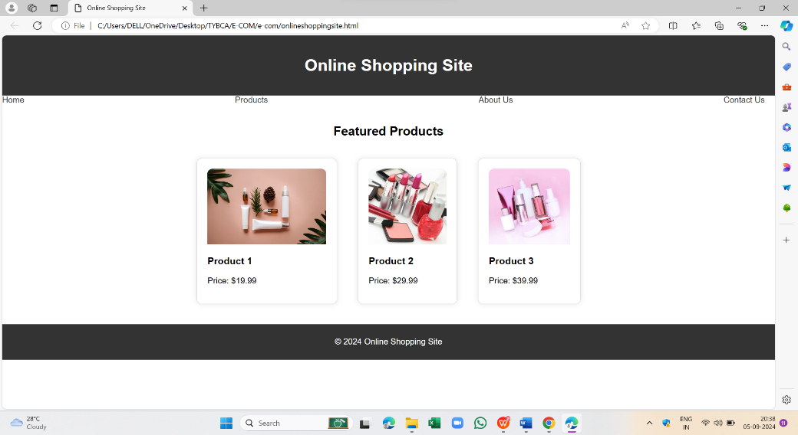

**Practical 3 : Create simple and static Feedback Form (web page) for online shopping site**

<!DOCTYPE html>

<html>

<head>

<title>Feedback Form</title>

</head>

<body>

<h2>Feedback Form</h2>

<form>

<label for="name">Name:</label>

<input type="text" id="name" name="name"><br><br>

<label for="email">Email:</label>

<input type="email" id="email" name="email"><br><br>

<label for="rating">Rating:</label>

<select id="rating" name="rating">

<option value="excellent">Excellent</option>

<option value="good">Good</option>

<option value="fair">Fair</option>

<option value="poor">Poor</option>

</select><br><br>

<label for="comments">Comments:</label>

<textarea id="comments" name="comments"></textarea><br><br>

<input type="submit" value="Submit">

</form>

</body>

</html>

Output:

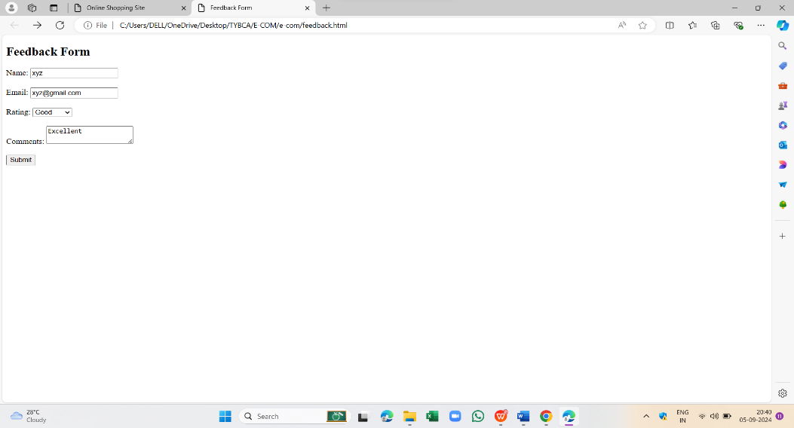

**Practical 4 : Create simple and static demo product catalog web page for online shopping site.**

**html file:**

<!DOCTYPE html>

<html>

<head>

<title>Product Catalog</title>

<link rel="stylesheet" href="first.css">

</head>

<body>

<h1>Product Catalog</h1>

<div class="categories">

<h2>Electronics</h2>

<ul>

<li>

<img src="https://tse3.mm.bing.net/th?id=OIP.nvdM5sEm4DqG8oZb8nNStQHaHa&pid=Api&P=0&h=180" alt="Smartphone">

<h3>Smartphone</h3>

<p>$999</p>

<p>Description: Latest smartphone with advanced features</p>

</li>

<li>

<img src="https://tse3.mm.bing.net/th?id=OIP.WCCq2nZelTZuFIRbJF7AuAHaEK&pid=Api&P=0&h=180" alt="Laptop">

<h3>Laptop</h3>

<p>$1,299</p>

<p>Description: High-performance laptop for work and play</p>

</li>

<li>

<img src="http://www.bhphotovideo.com/images/images2500x2500/samsung_sm_w700nzkaxar_12_0_tabpro_s_tablet_1222108.jpg" alt="Tablet">

<h3>Tablet</h3>

<p>$499</p>

<p>Description: Portable tablet for entertainment and productivity</p>

</li>

</ul>

</div>

<div class="categories">

<h2>Fashion</h2>

<ul>

<li>

<img src="https://tse2.mm.bing.net/th?id=OIP.T5ssTzuJLHDMrtc9U39mywHaJQ&pid=Api&P=0&h=180" alt="T-Shirt">

<h3>T-Shirt</h3>

<p>$19.99</p>

<p>Description: Comfortable and stylish t-shirt for men</p>

</li>

<li>

<img src="https://tse2.mm.bing.net/th?id=OIP.YjEEUjhS5TZIMPf5_LCdIwHaKl&pid=Api&P=0&h=180" alt="Dress">

<h3>Dress</h3>

<p>$49.99</p>

<p>Description: Elegant and fashionable dress for women</p>

</li>

<li>

<img src="https://tse1.mm.bing.net/th?id=OIP.YguOkIP2xIjpoReX_q0R4gHaHa&pid=Api&P=0&h=180" alt="Shoes">

<h3>Shoes</h3>

<p>$79.99</p>

<p>Description: Stylish and comfortable shoes for men and women</p>

</li>

</ul>

</div>

<div class="categories">

<h2>Home Appliances</h2>

<ul>

<li>

<img src="https://images-na.ssl-images-amazon.com/images/G/01/th/aplus/samsung/samsung-B00COKDO0M-1-l.jpg" alt="Refrigerator">

<h3>Refrigerator</h3>

<p>$1,099</p>

<p>Description: Energy-efficient refrigerator for your kitchen</p>

</li>

<li>

<img src="https://www.lg.com/in/images/washing-machines/md07540887/gallery/FHM1408BDL-Washing-Machines-Right-View-MZ-04-v1.jpg" alt="Washing Machine">

<h3>Washing Machine</h3>

<p>$899</p>

<p>Description: High-performance washing machine for your laundry needs</p>

</li>

<li>

<img src="https://i.pinimg.com/originals/88/8f/00/888f003bfbfe07cb8fe85b0a7365a185.jpg" alt="Air Conditioner">

<h3>Air Conditioner</h3>

<p>$1,499</p>

<p>Description: Powerful and energy-efficient air conditioner for your home</p>

</li>

</ul>

</div>

<button>Add to Cart</button>

<button>Checkout</button>

</body>

</html>

**css file:**

body {

font-family: Arial, sans-serif;

margin: 20px;

}

.categories {

margin-bottom: 20px;

}

.categories h2 {

margin-top: 0;

}

ul {

list-style: none;

padding: 0;

}

li {

margin-bottom: 20px;

}

img {

width: 100px;

height: 100px;

margin-right: 20px;

}

h3 {

margin-top: 0;

}

button {

background-color: #4CAF50;

color: #fff;

padding: 10px 20px;

border: none;

border-radius: 5px;

cursor: pointer;

}

button:hover {

background-color: #3e8e41;

}

**Output:**

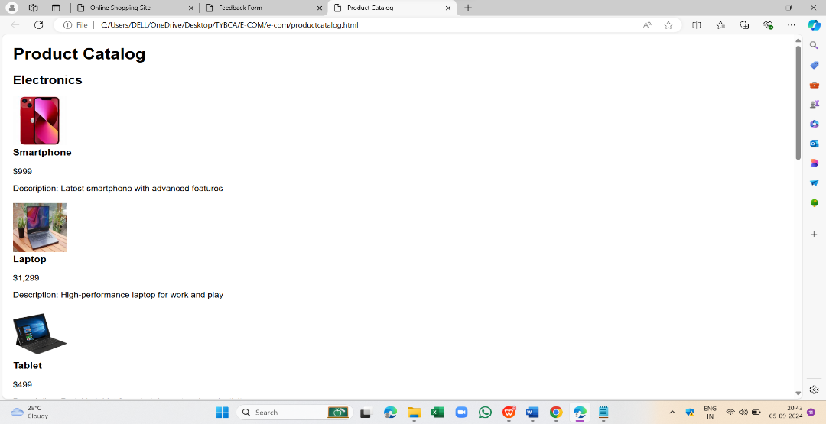

Prac 5: Demonstrate domain registration

Domain Registration

Step 1:Go to Google Chrome

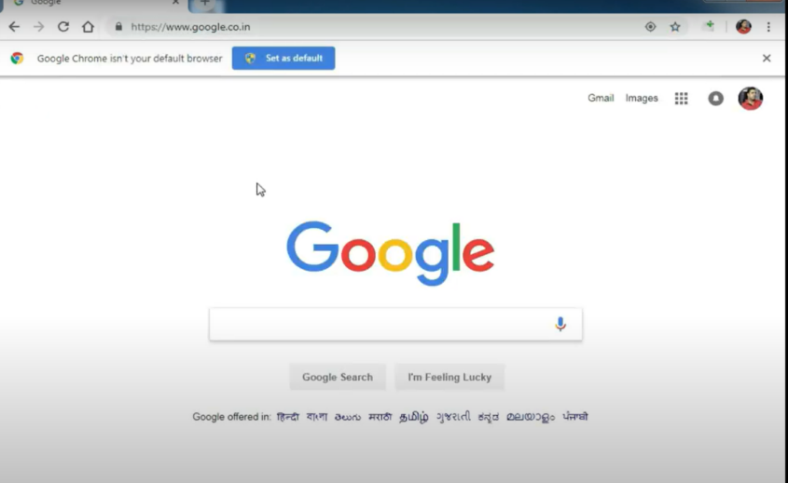

Step 2: Search for Domain name registration 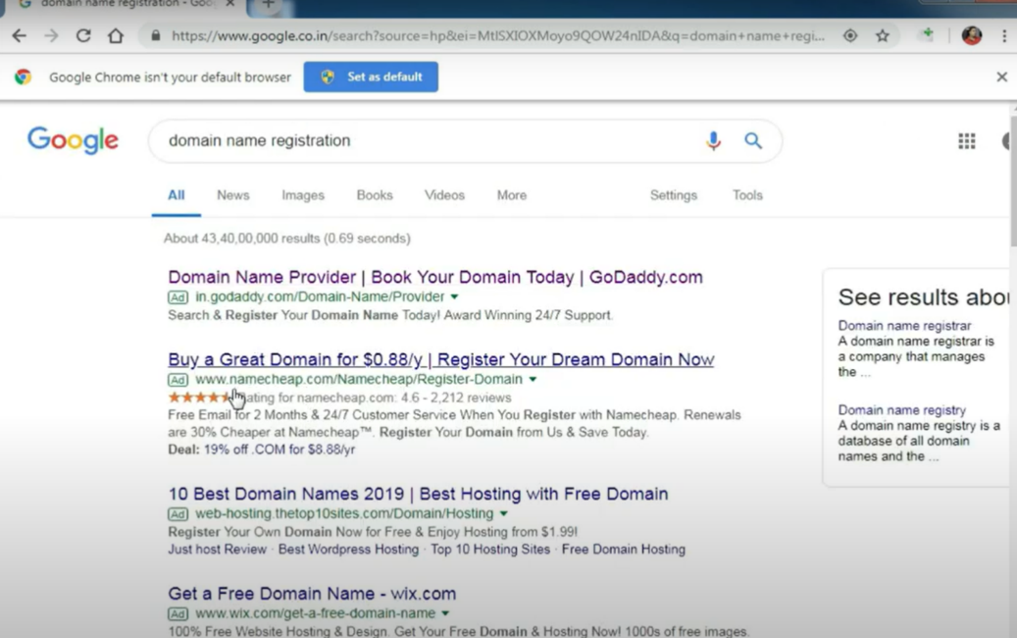

Step 3: you will see various websites, choose one that you prefer like Godaddy 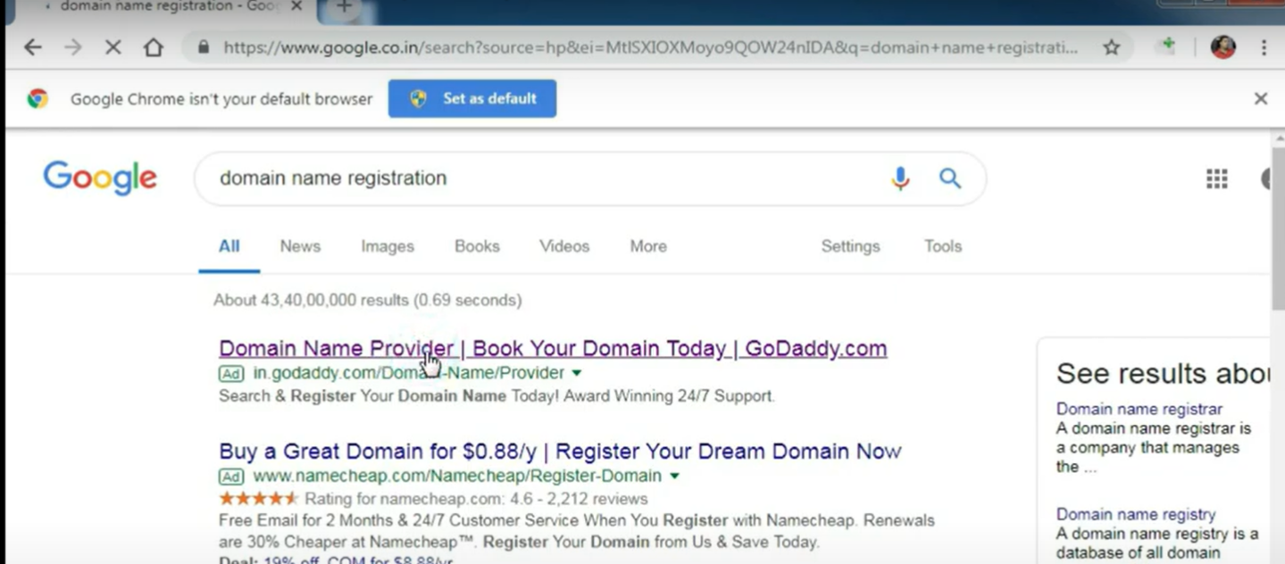

Step 4:Search name that you want to register as a domain 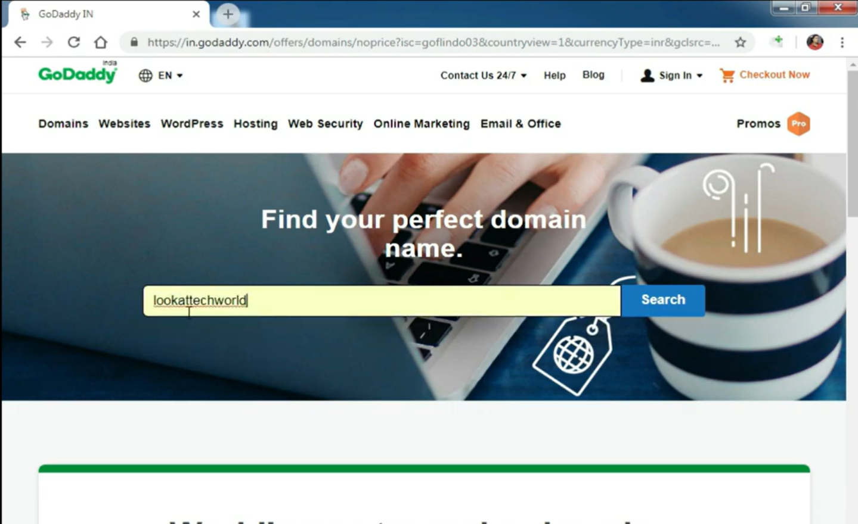

Step 5: see if it is available or not 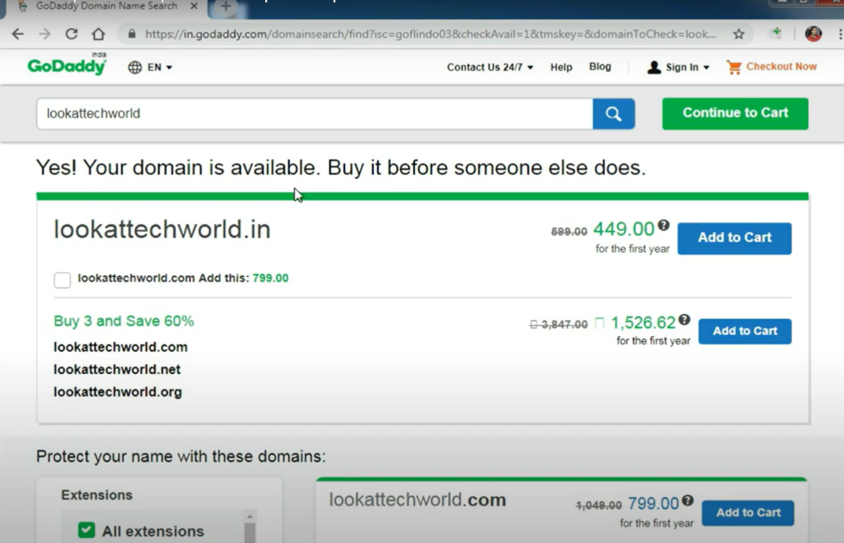

Step 6: you also try the name with .com 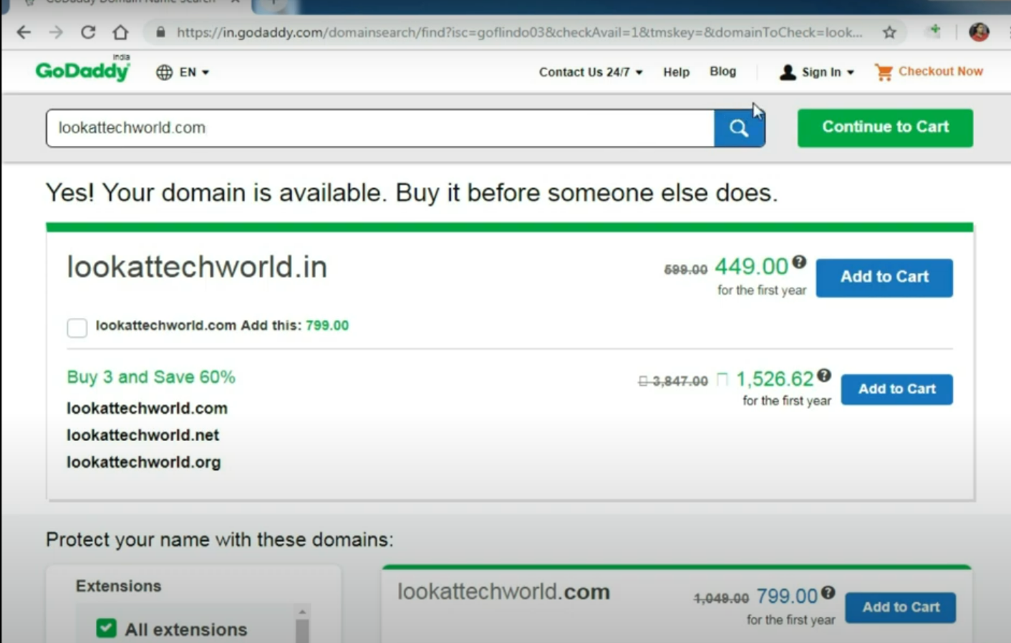

Step 7: Click on Add to Cart of the name you want 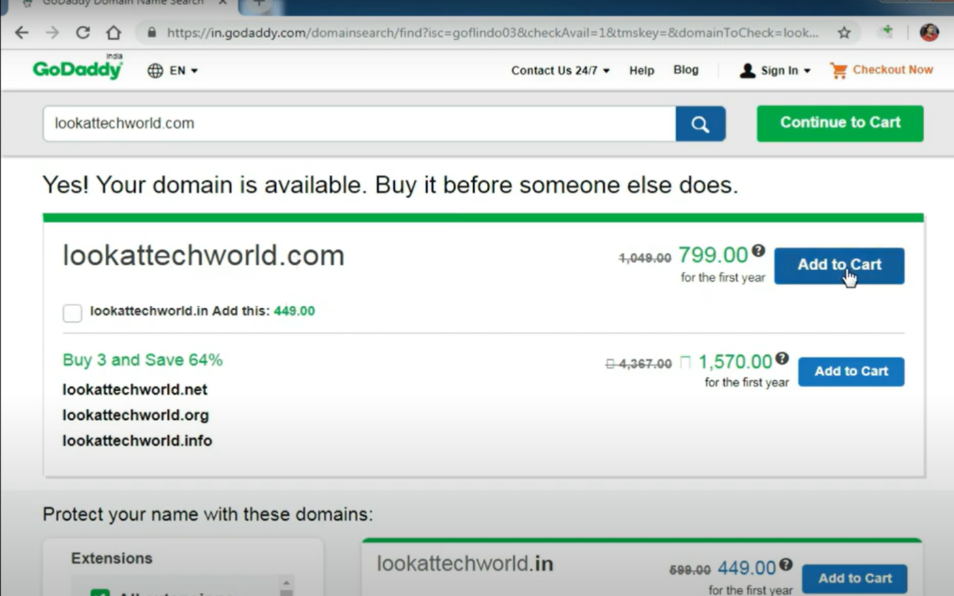

Step 8: you can see various extension 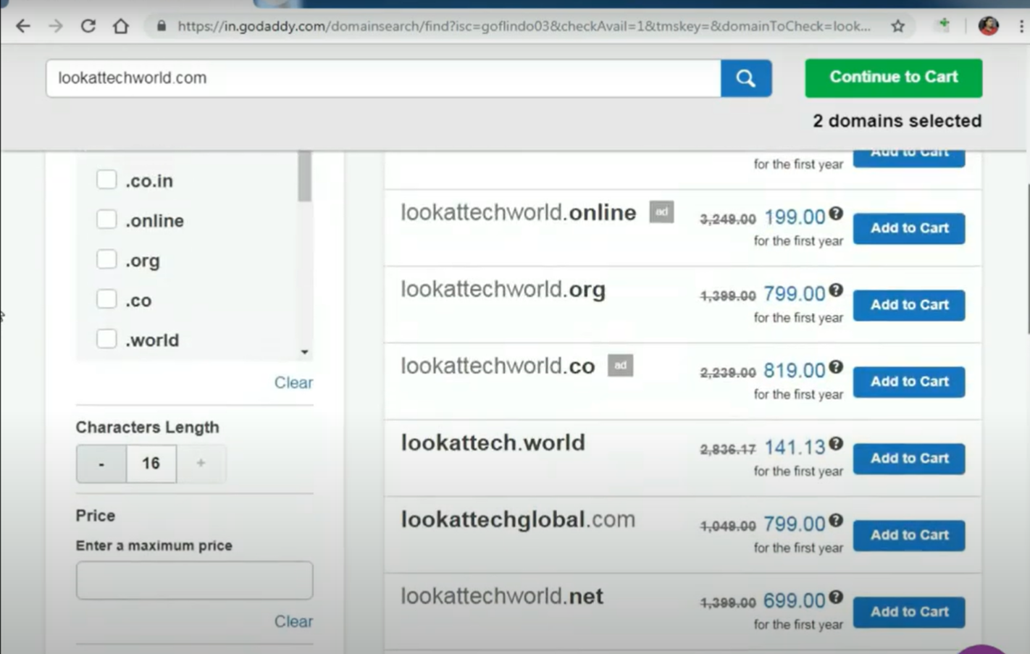

Step 9:you can select any extension like .in 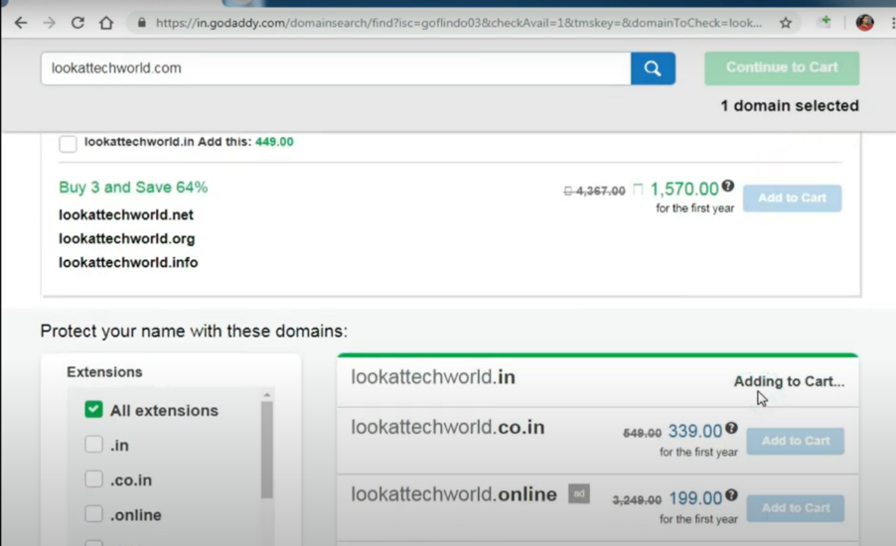 Step 10:Click on checkout no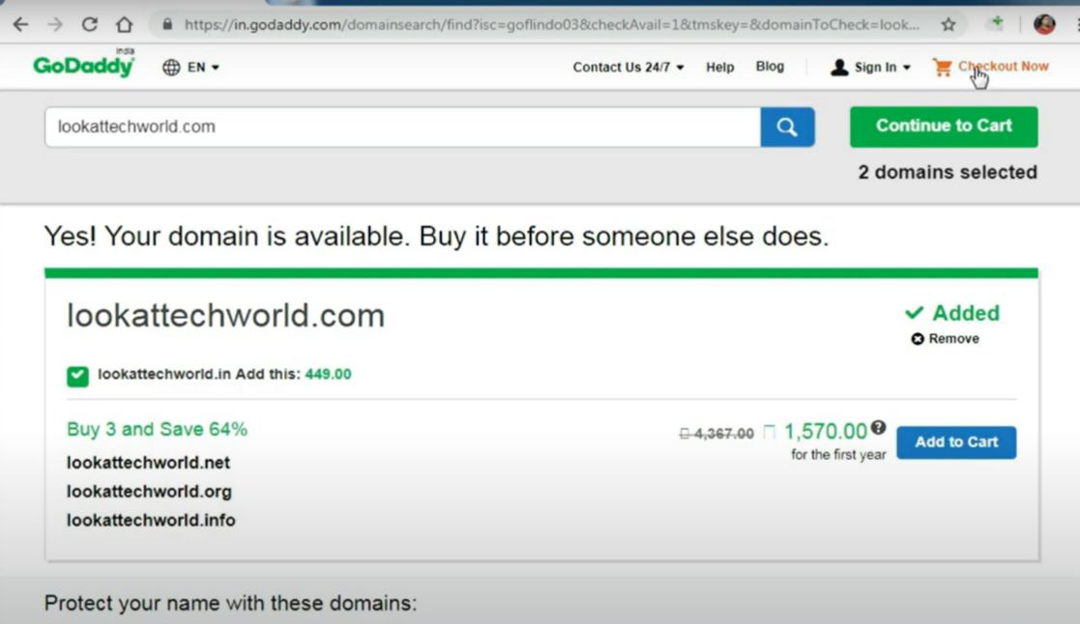w

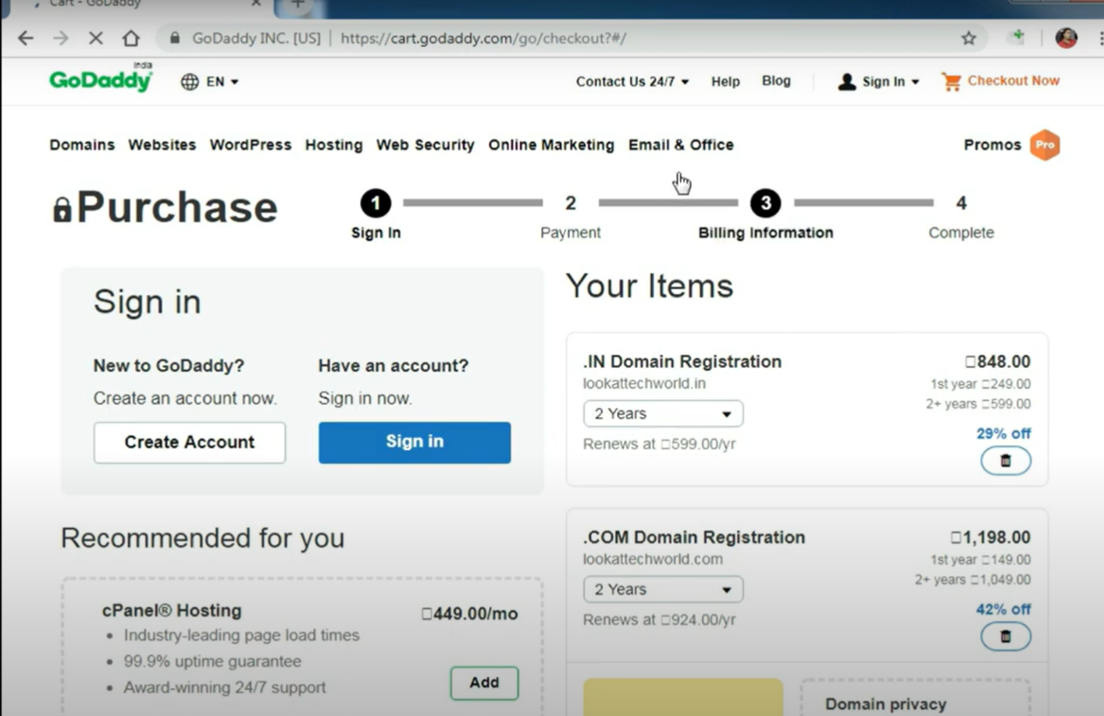

Step 11:If you have a problem, you can contact customer service 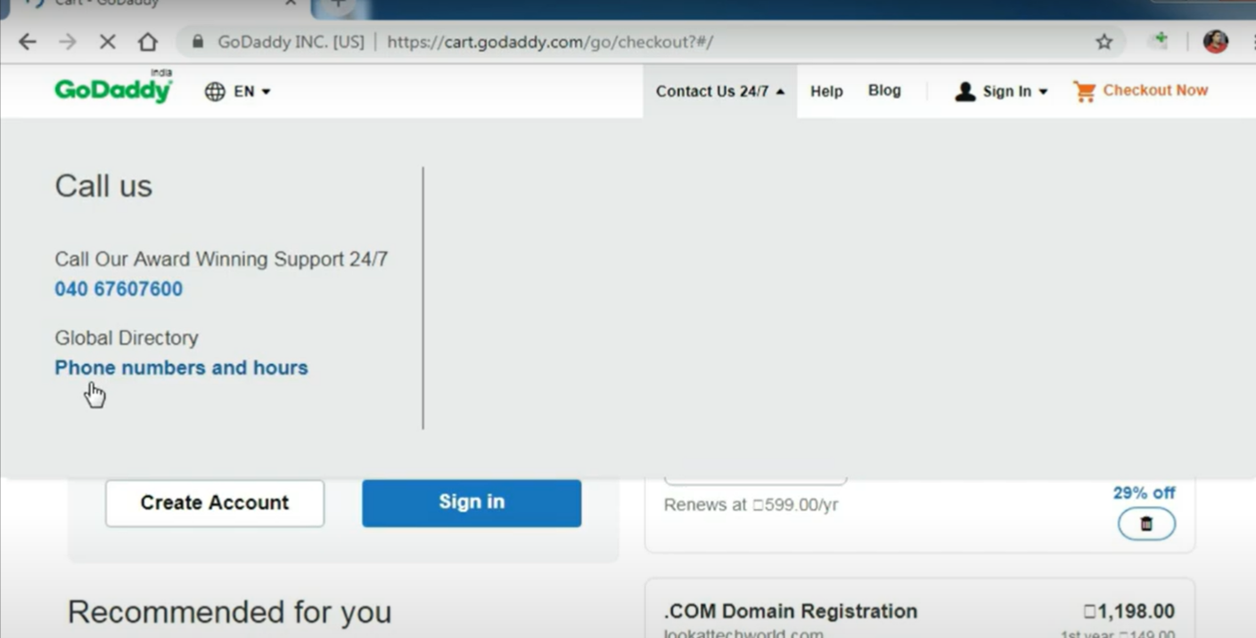

Check for any extra services that are already added in

Step 12: You can choose the duration of the extension 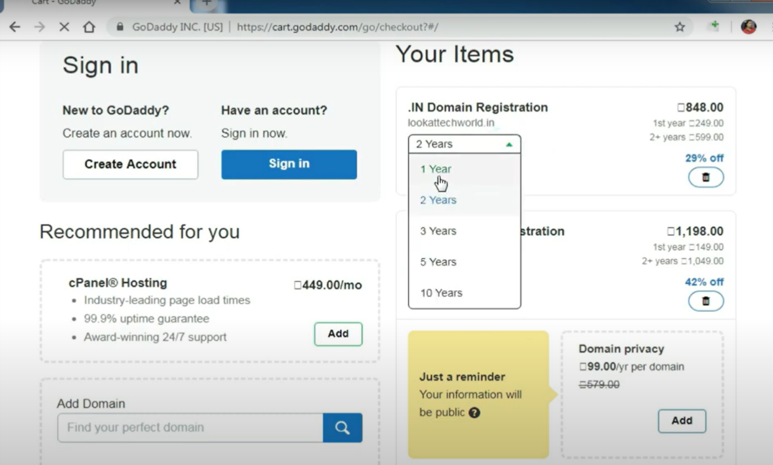

Step 13: You can remove the extensions 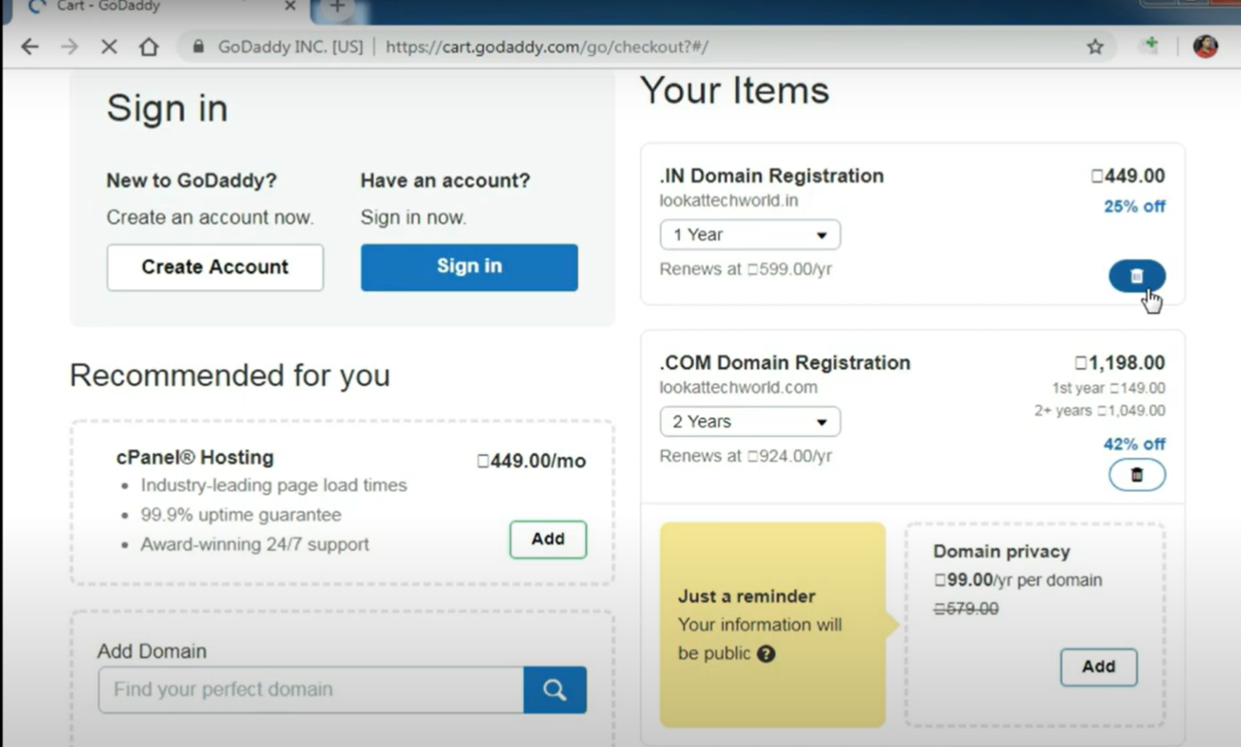

Step 14: You can choose the duration of the domain name 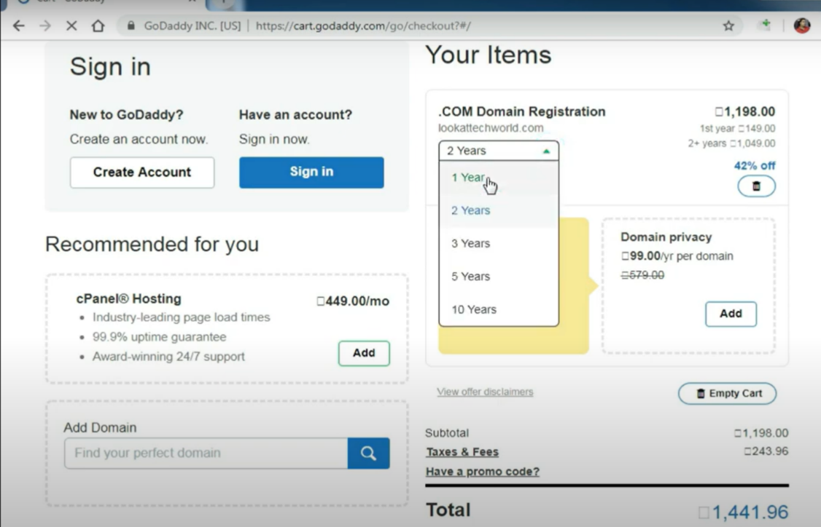

Step 15: If you already have an account sign in, if not then go to Create account 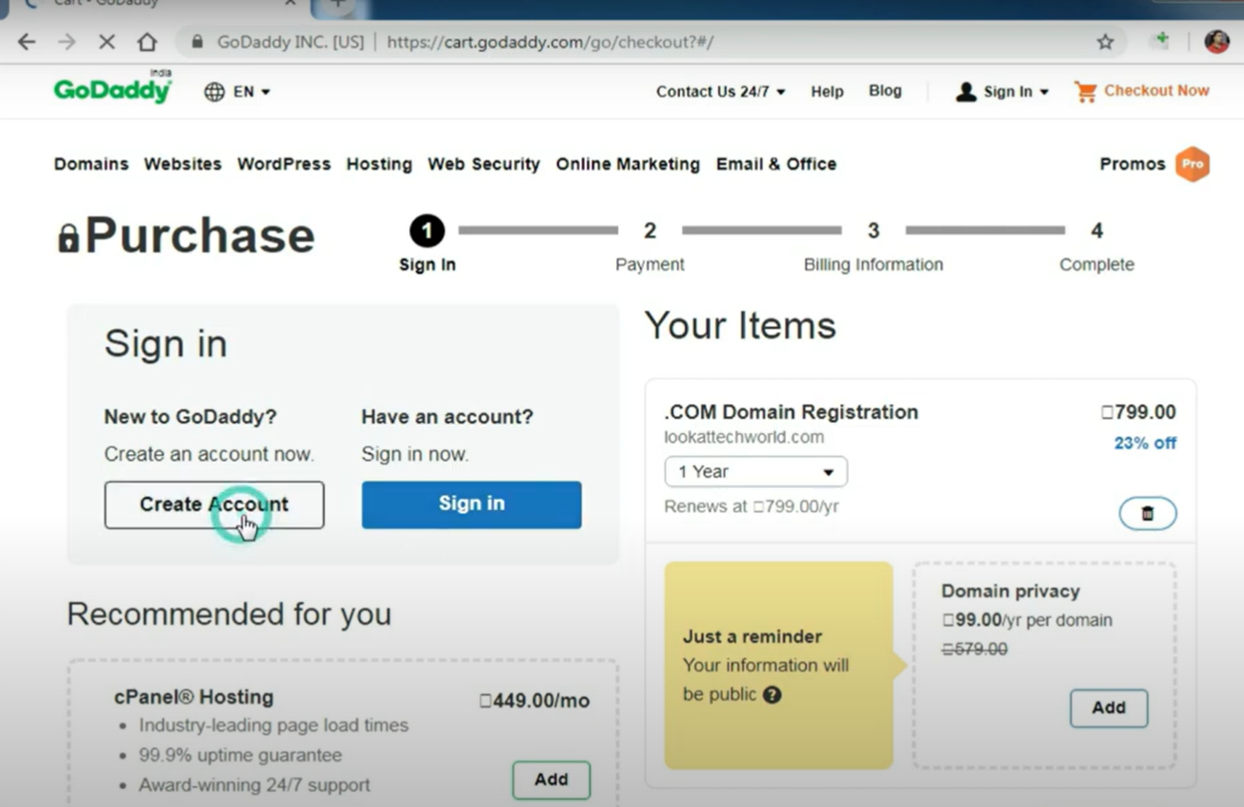

Step 16: Type the email of the domain you want and you will see by default, the username will be referred to the email, you can customize the username 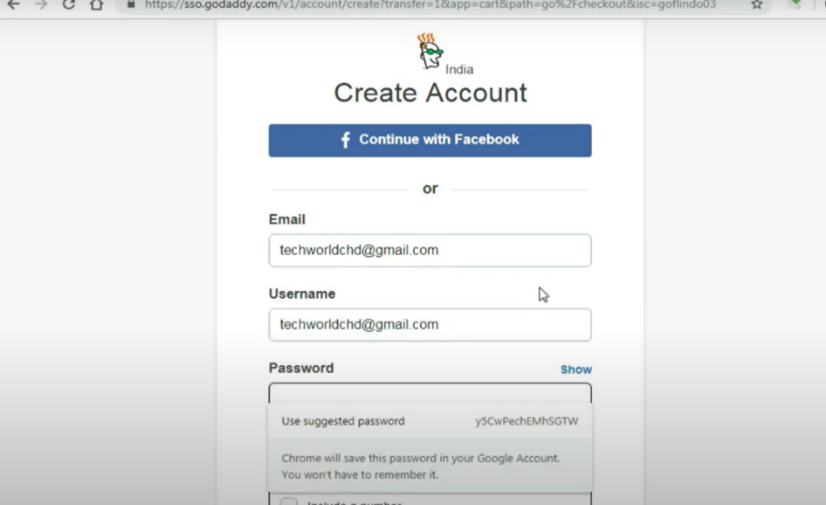

Step 17: Type the password and pin that match the conditions 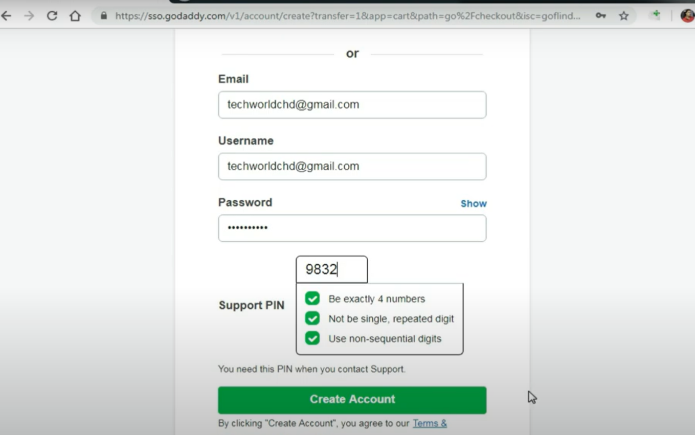

Step 18:Click on Create account 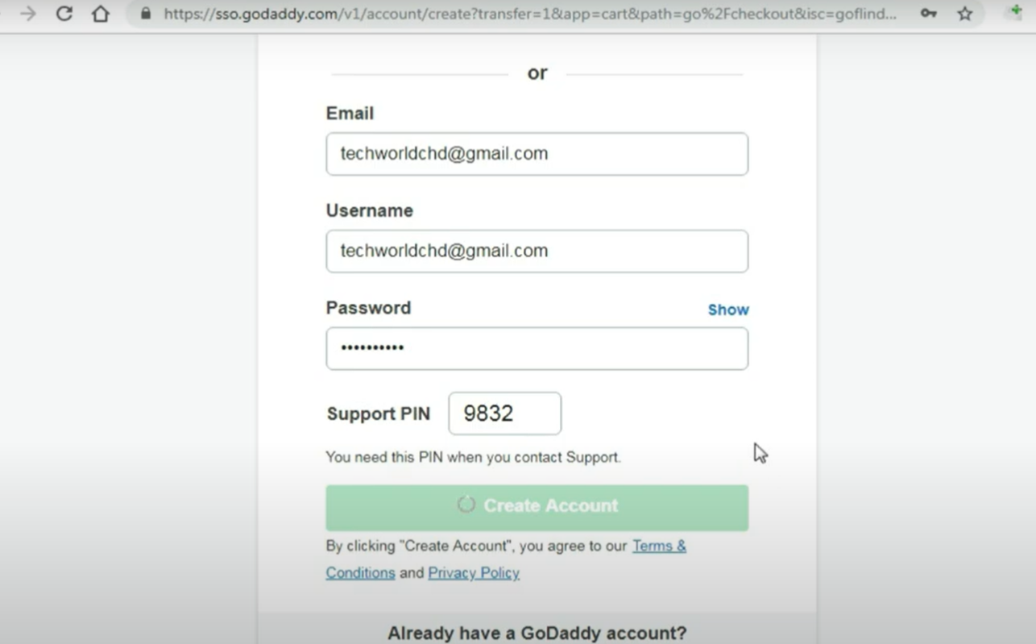

Step 19: Fill billing information 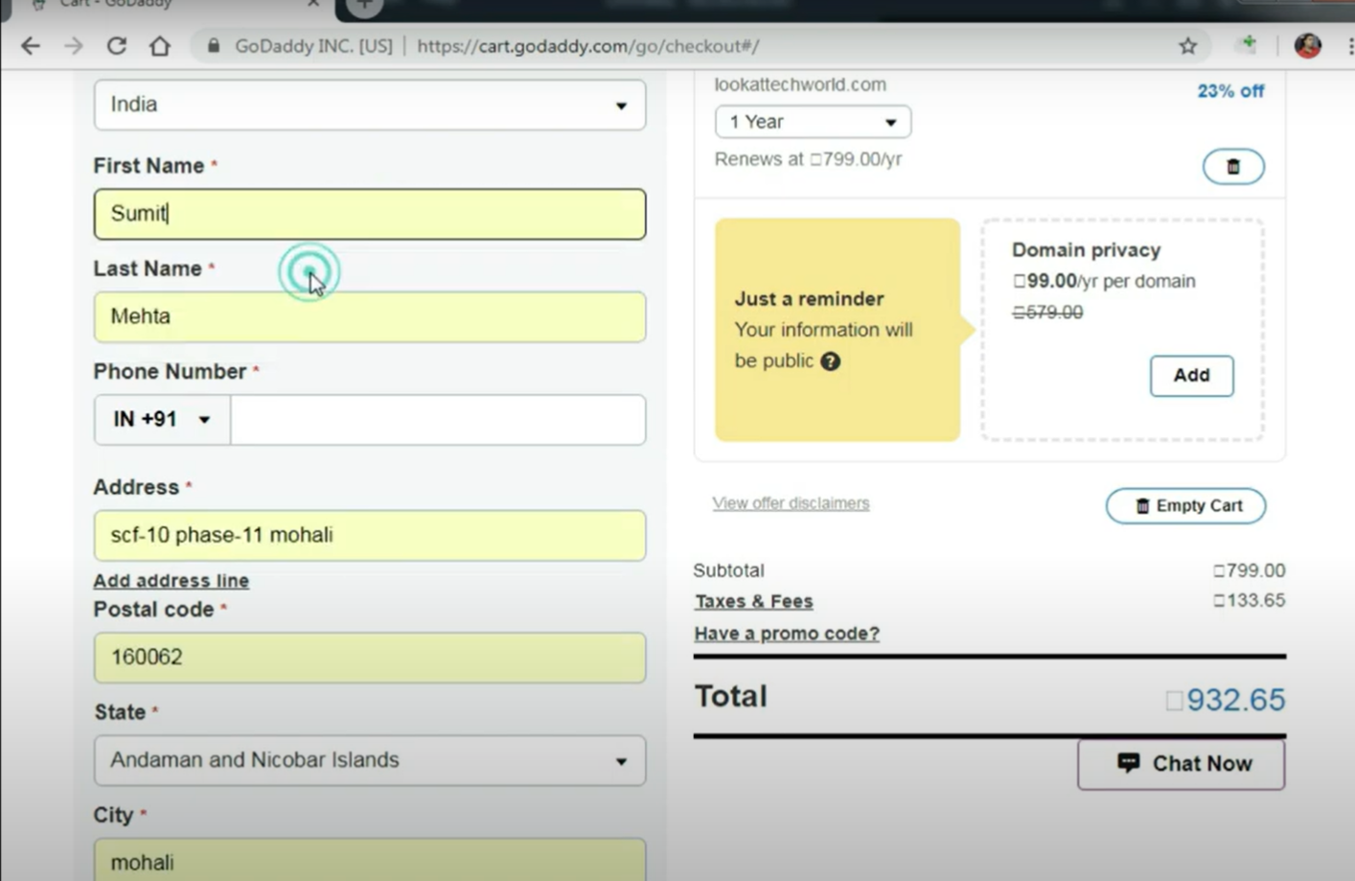

Step 20: If you have a company, type its name and GSTno.

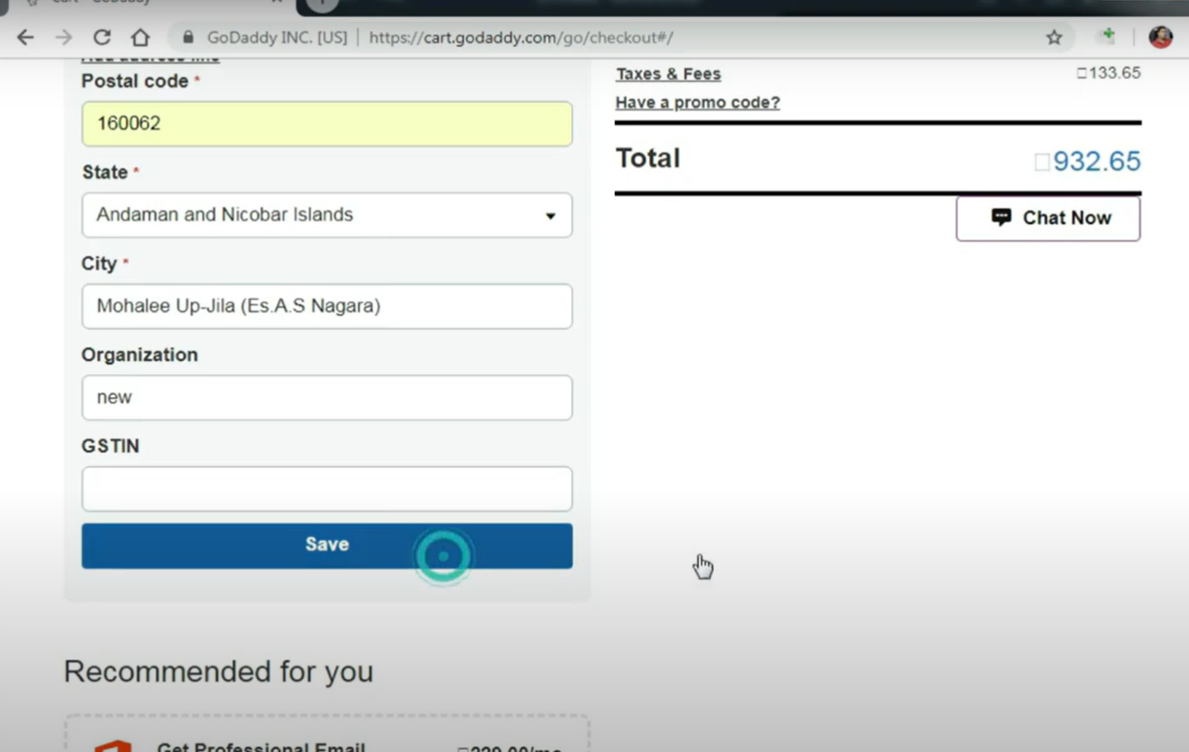

Step 21: Fill your contact number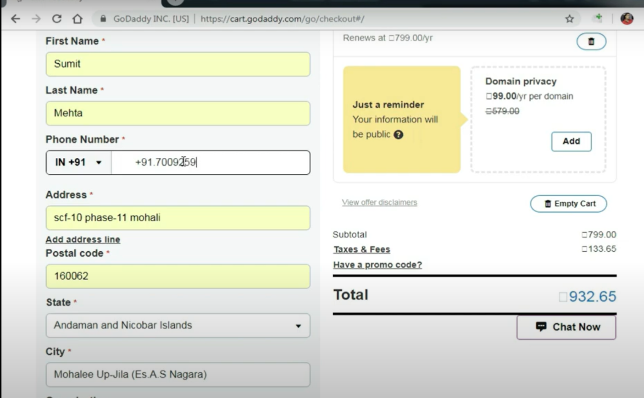

Step 22: Click on save



Step 23: You will see the payment process you choose the mode of payment like a a a credit card, net banking, etc. 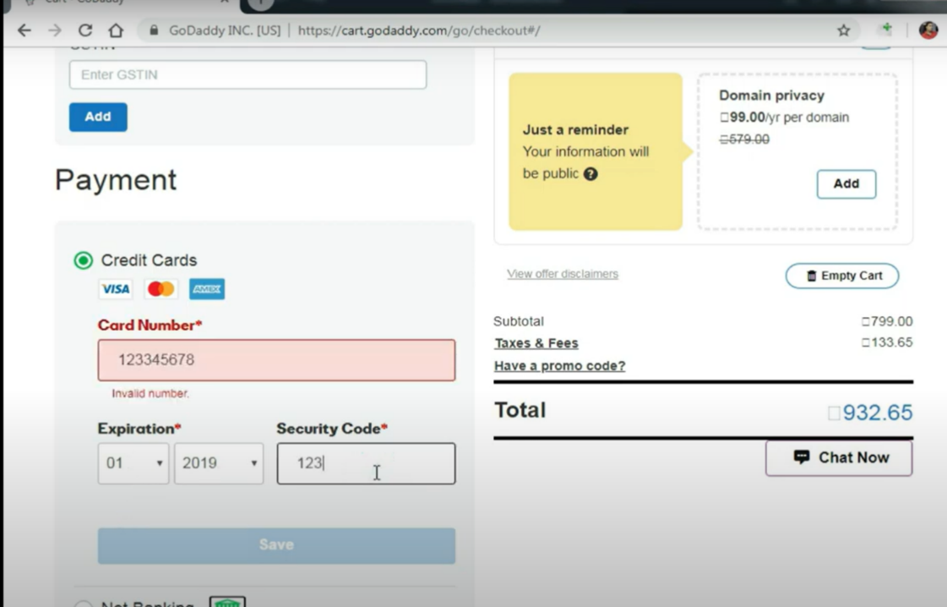

Step 24: Click on complete purchase 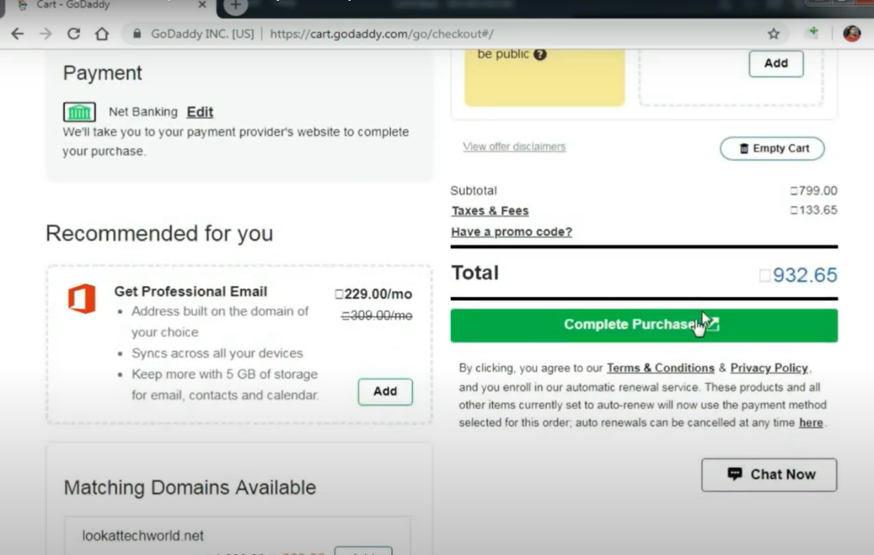

Step 25: It will show a filling page, check your information 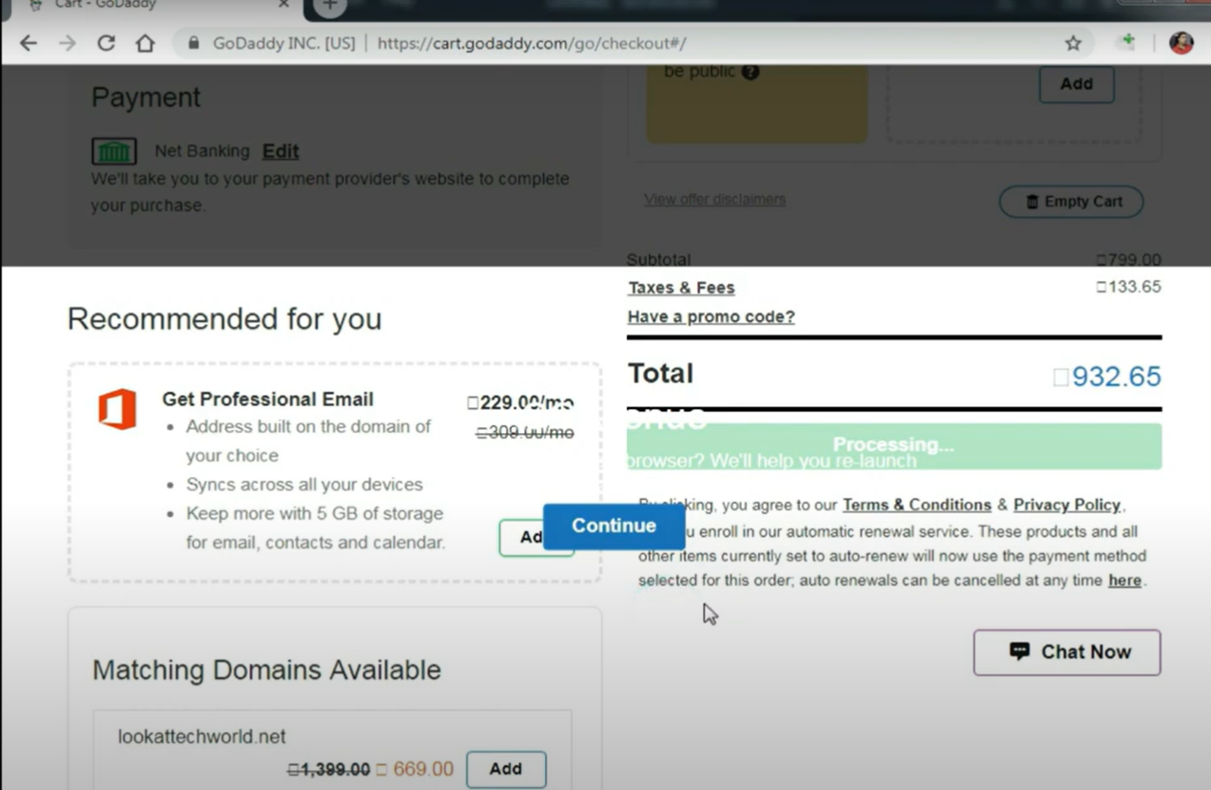

Step 26: Click on continue and on submit and there you have got your domain name 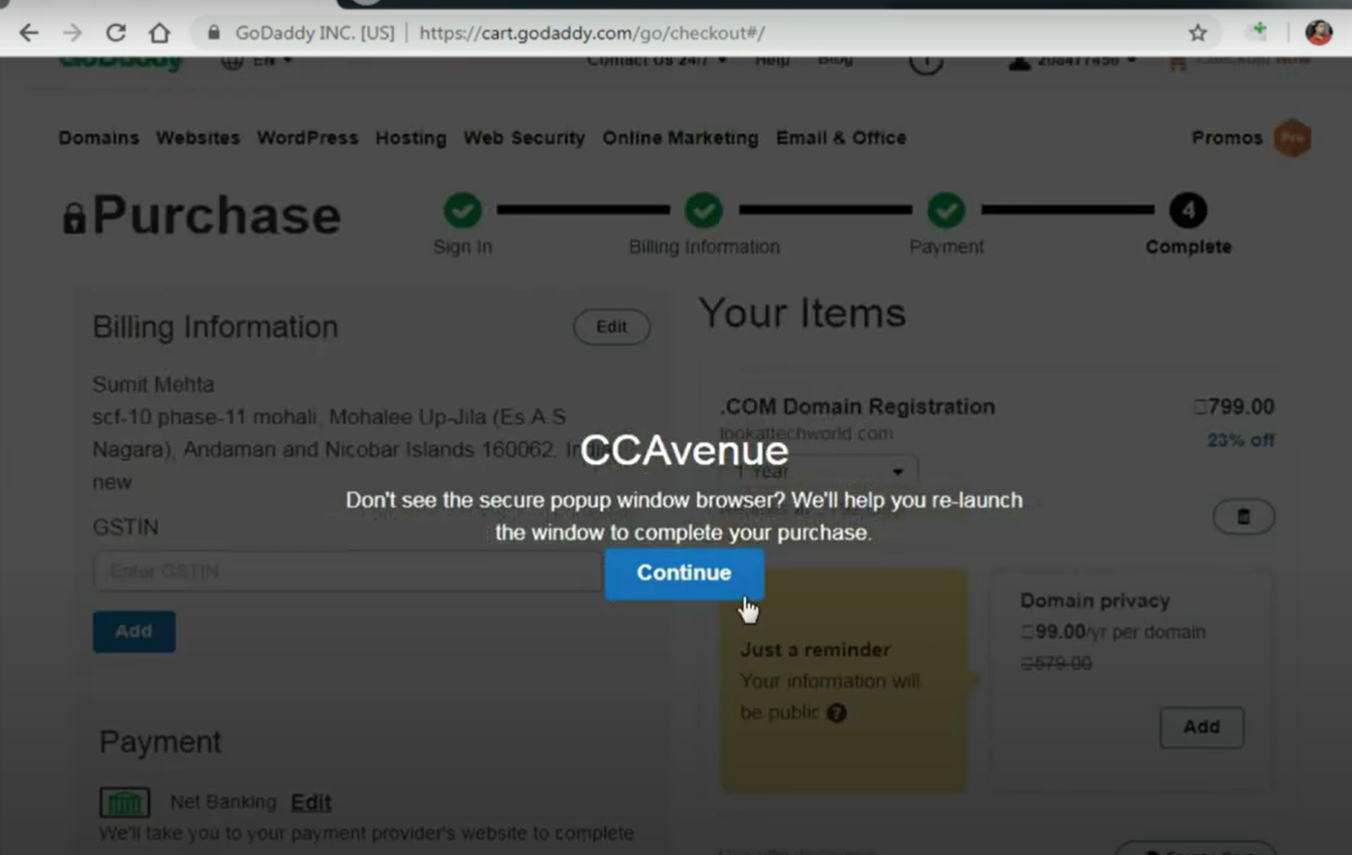 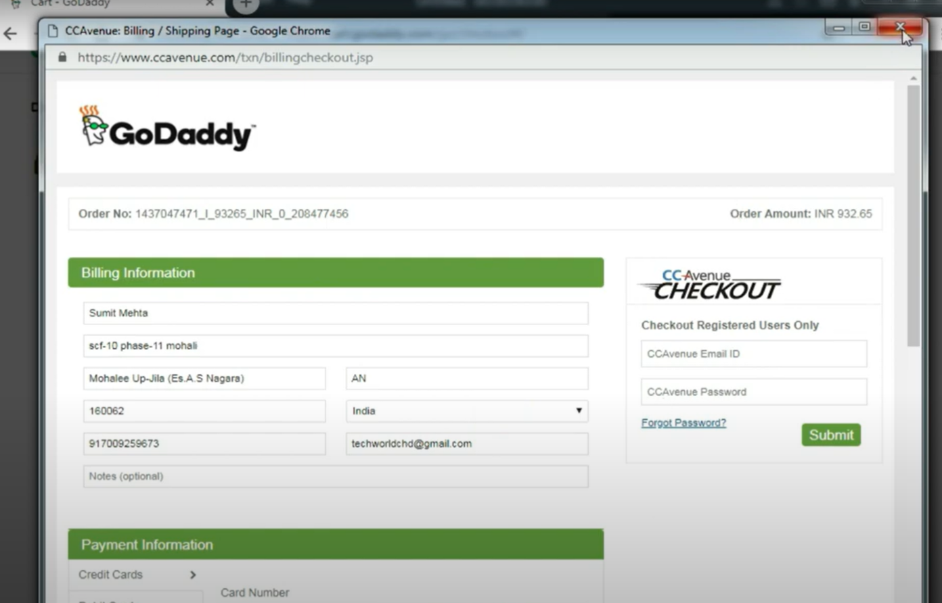

Step 27: Go to the Godaddy page, you will see your domain name

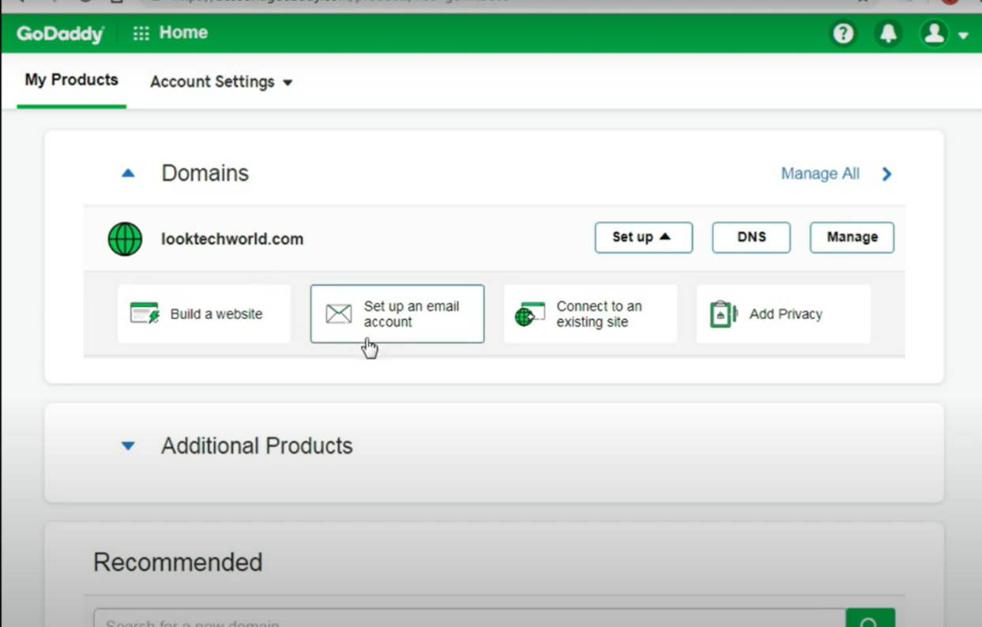

Step 28: Copy the name and paste it into the address b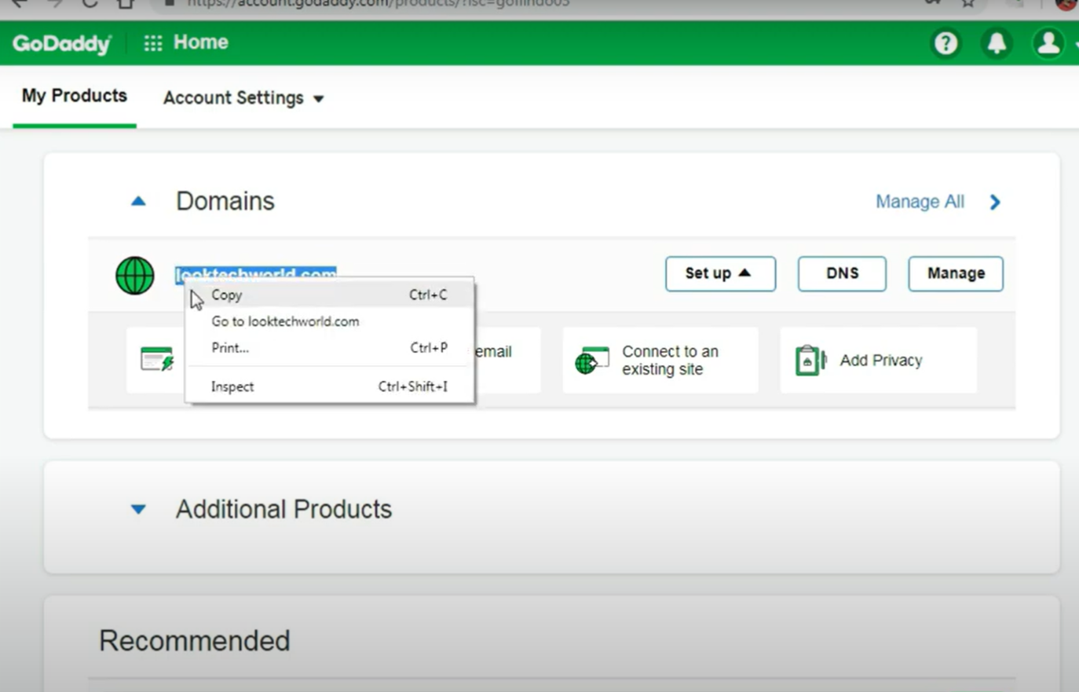ar 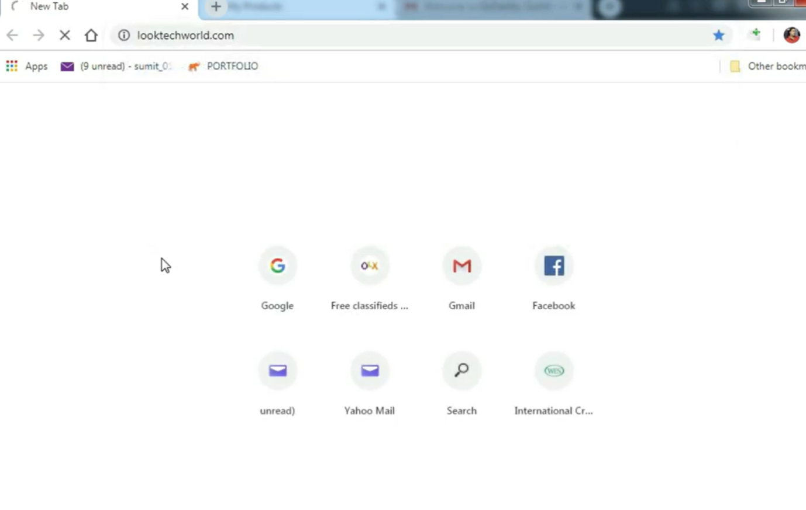

Step 29: You will be redirected to the GoDaddy page because your site has not been connected to hosting, only the domain is registered 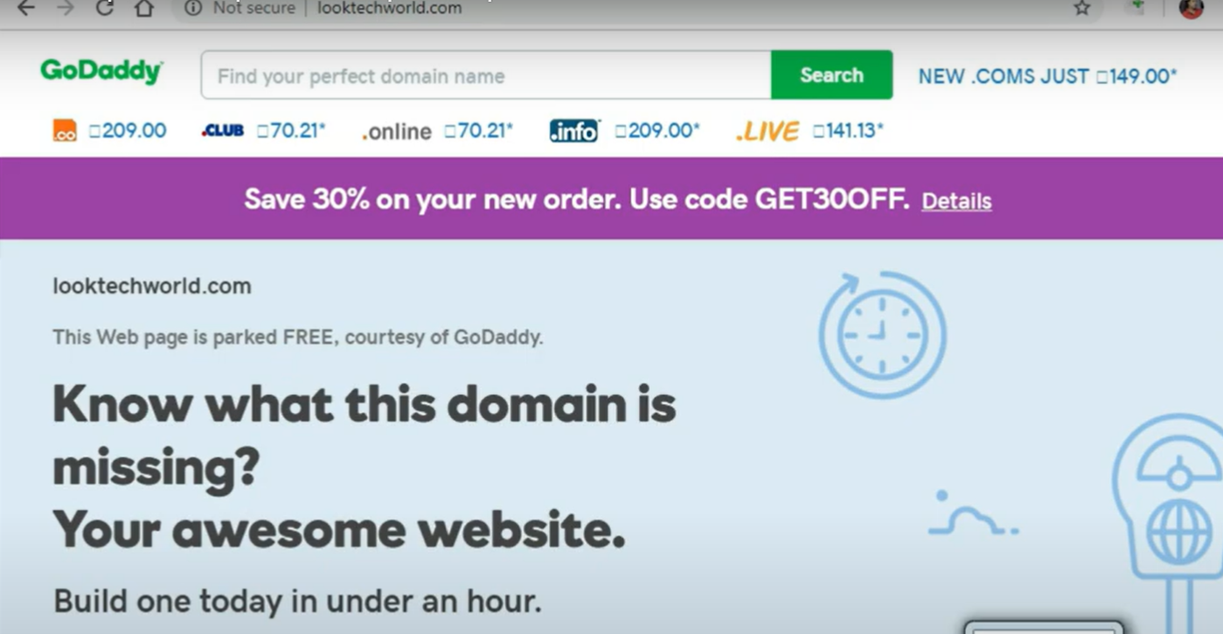

Prac 6: Search web hosting plans with configuration

HTML (index.html):

<!DOCTYPE html>

<html lang="en">

<head>

    <meta charset="UTF-8">

    <meta name="viewport" content="width=device-width, initial-scale=1.0">

    <title>E-commerce Website</title>

    <link rel="stylesheet" href="prac6.css">

</head>

<body>

    <header>

        <nav>

            <ul>

                <li><a href="#">Home</a></li>

                <li><a href="#">Products</a></li>

                <li><a href="#">Cart</a></li>

            </ul>

        </nav>

    </header>

    <main>

        <section class="products">

            <h2>Products</h2>

            <div class="product">

                <img src=img1.jpg alt="Product 1">

                <h3>Product 1</h3>

                <p>Price: $19.99</p>

                <button>Add to Cart</button>

            </div>

            <div class="product">

                <img src=img2.jpg alt="Product 2">

                <h3>Product 2</h3>

                <p>Price: $29.99</p>

                <button>Add to Cart</button>

            </div>

        </section>

    </main>

    <script src="prac6.js"></script>

</body>

</html>

CSS:

body {

    font-family: Arial, sans-serif;

    margin: 0;

    padding: 0;

}

header {

    background-color: #333;

    color: #fff;

    padding: 1em;

    text-align: center;

}

nav ul {

    list-style: none;

    margin: 0;

    padding: 0;

    display: flex;

    justify-content: space-between;

}

nav li {

    margin-right: 20px;

}

nav a {

    color: #fff;

    text-decoration: none;

}

.products {

    display: flex;

    flex-wrap: wrap;

    justify-content: center;

}

.product {

    margin: 20px;

    padding: 20px;

    border: 1px solid #ddd;

    border-radius: 10px;

    box-shadow: 0 0 10px rgba(0, 0, 0, 0.1);

}

.product img {

    width: 100%;

    height: 150px;

    object-fit: cover;

    border-radius: 10px 10px 0 0;

}

.product h3 {

    font-weight: bold;

    margin-top: 0;

}

.product p {

    font-size: 18px;

    color: #666;

}

.product button {

    background-color: #333;

    color: #fff;

    border: none;

    padding: 10px 20px;

    font-size: 18px;

    cursor: pointer;

}

.product button:hover {

    background-color: #555;

}

JAVASCript:

// Add event listeners to add to cart buttons

document.querySelectorAll('.product button').forEach(button => {

    button.addEventListener('click', () => {

        // Add product to cart logic here

        console.log('Product added to cart!');

    });

});

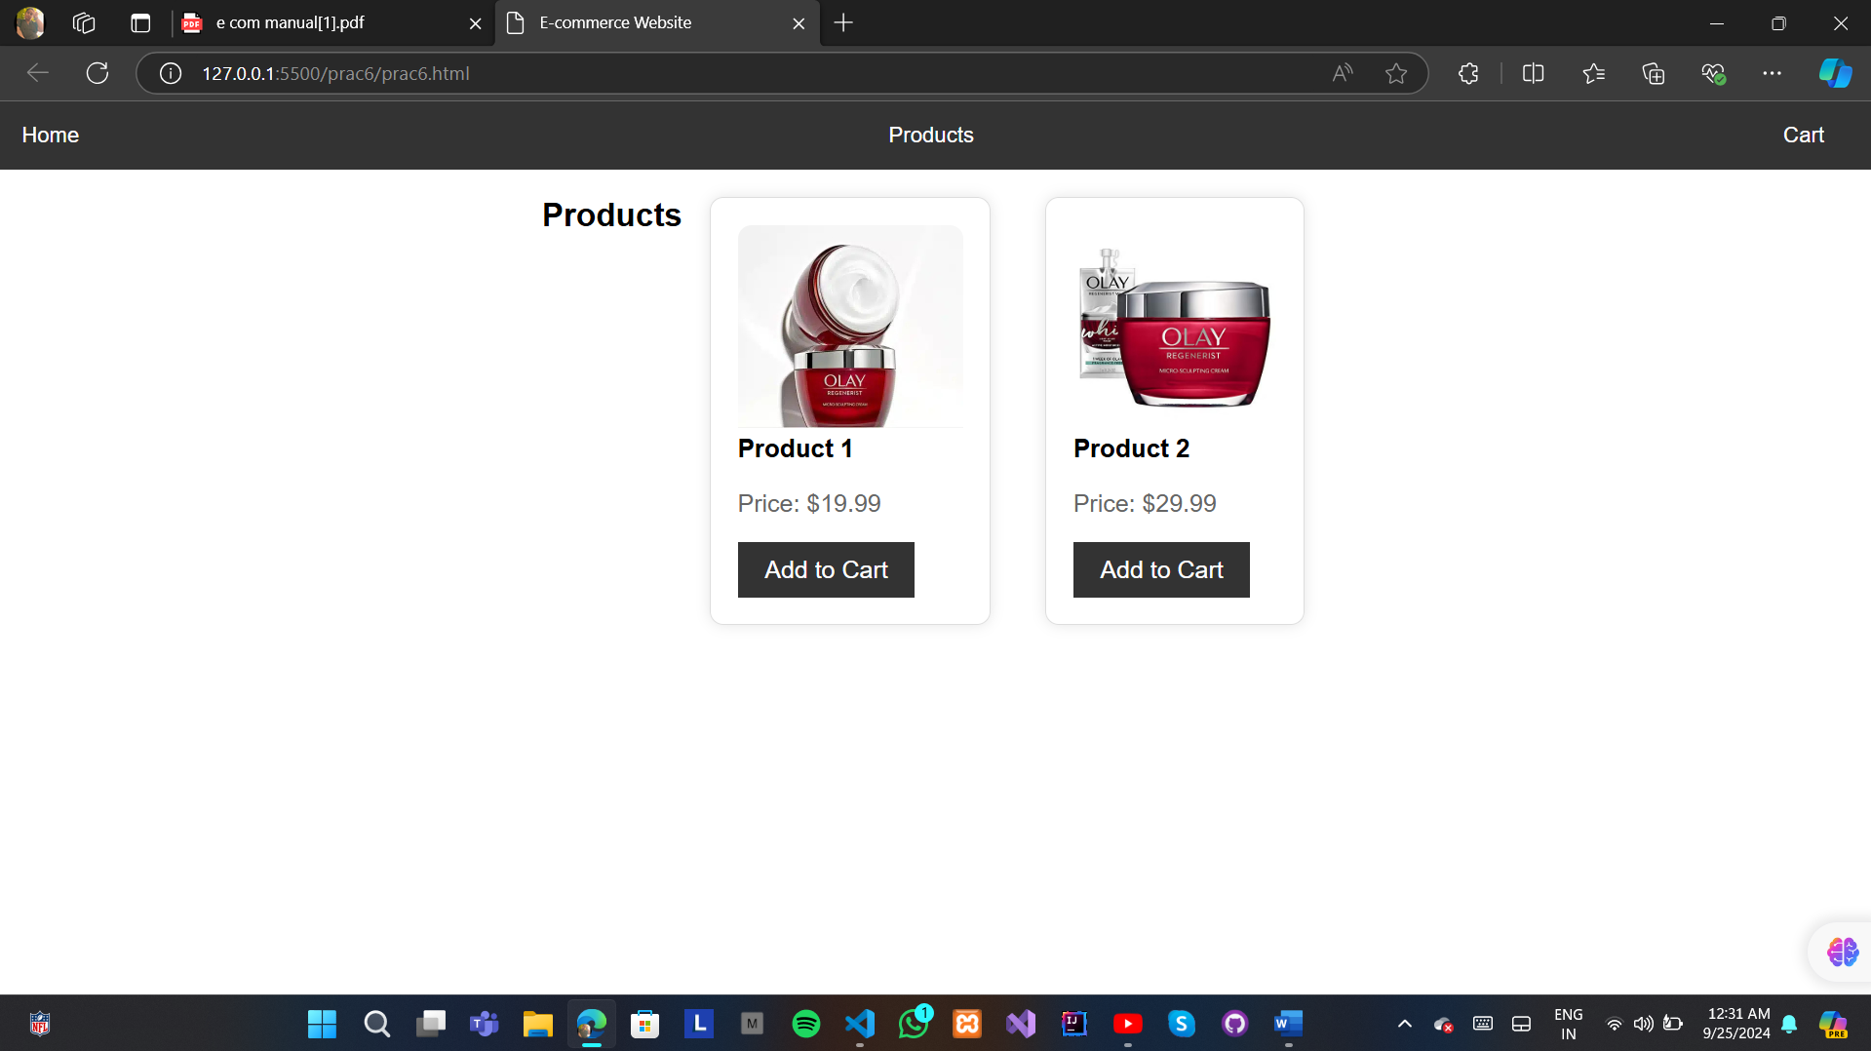

Prac 7: Demonstrate free hosting with control panel

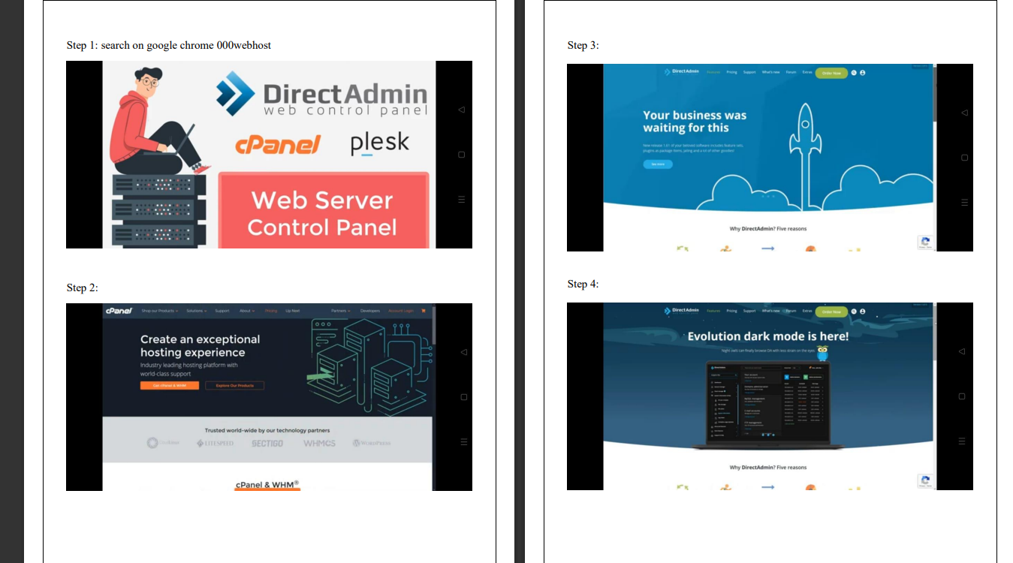

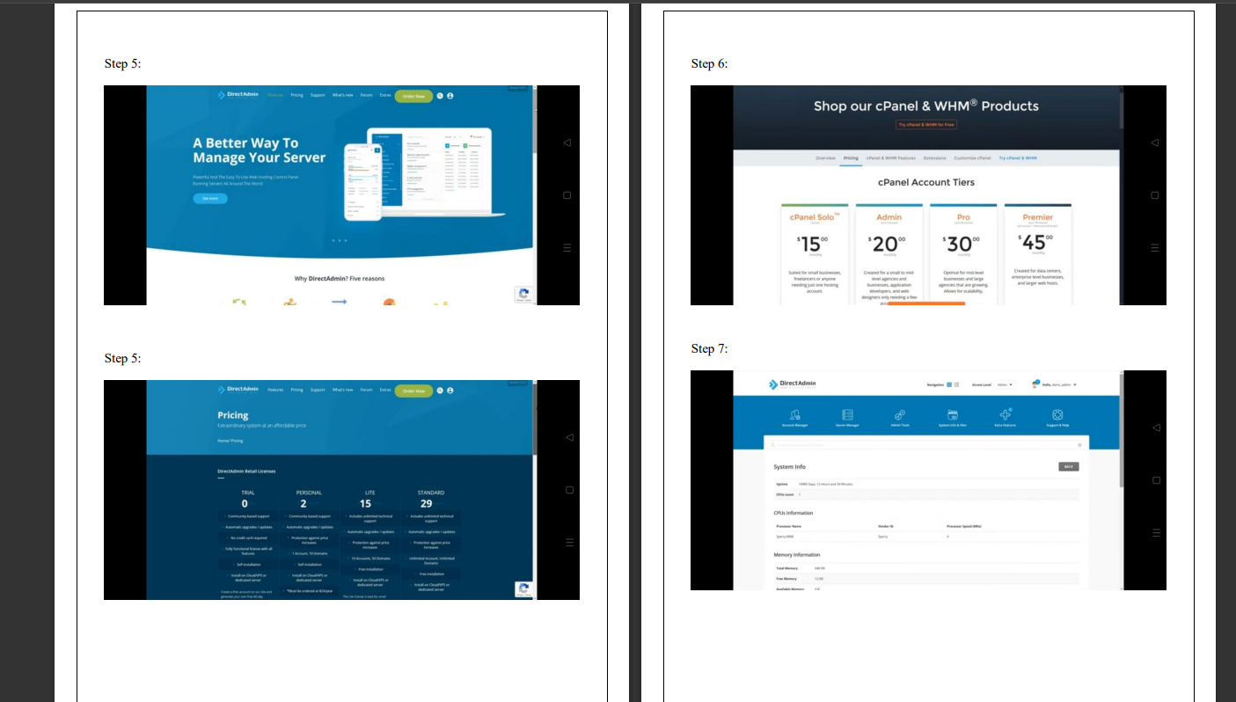

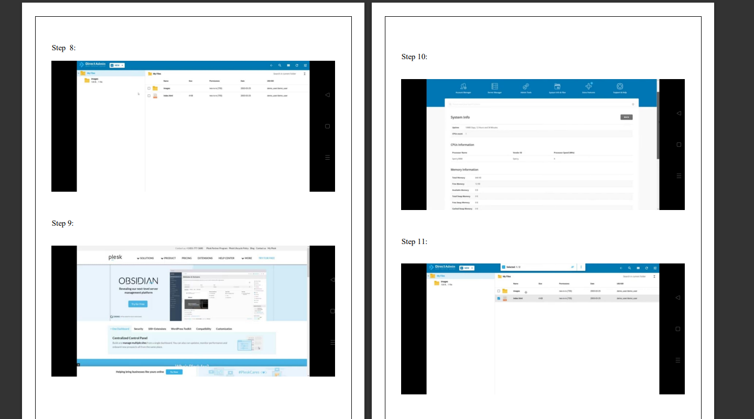

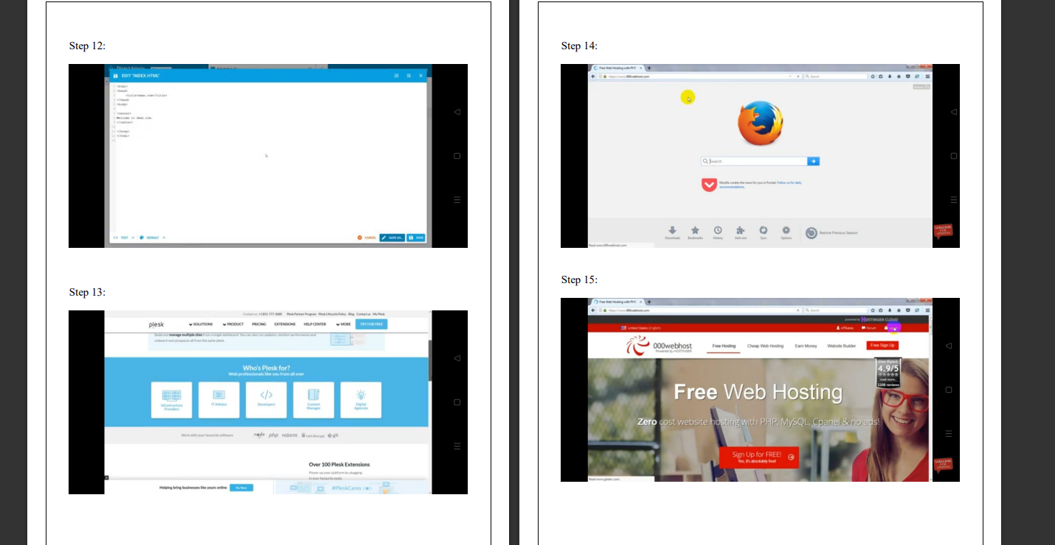

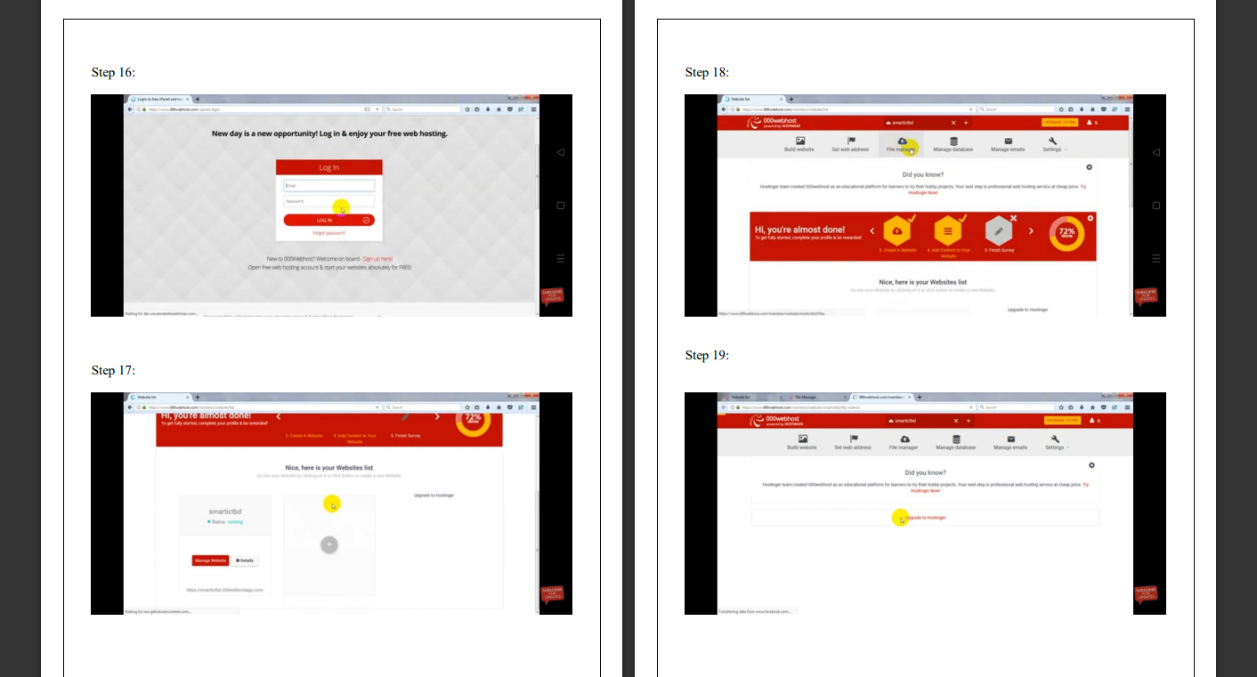

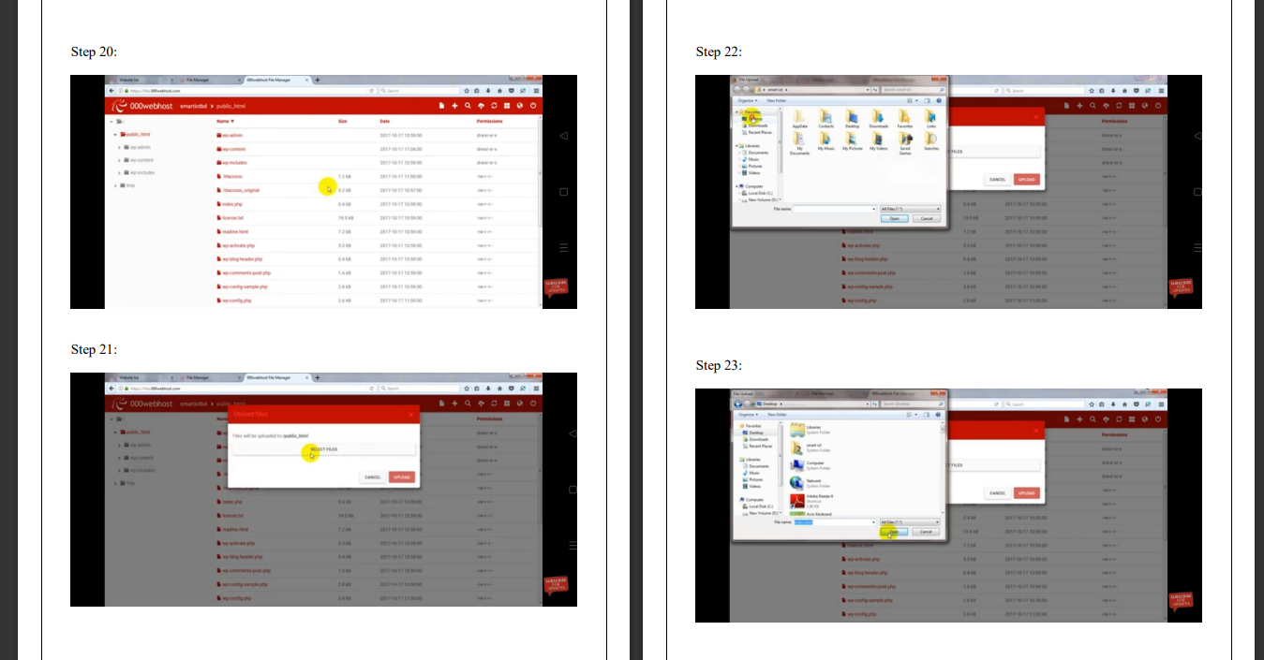

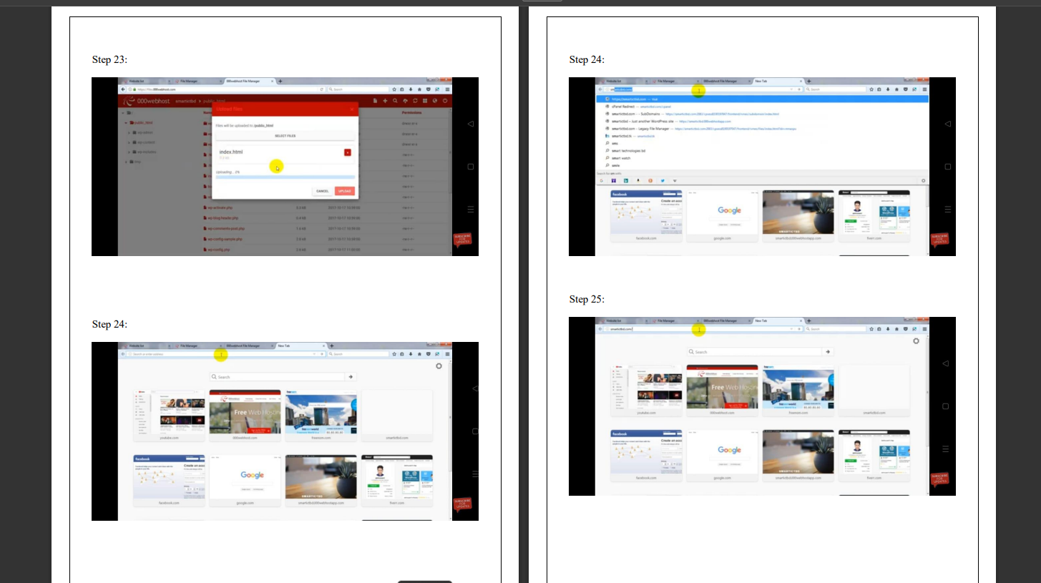

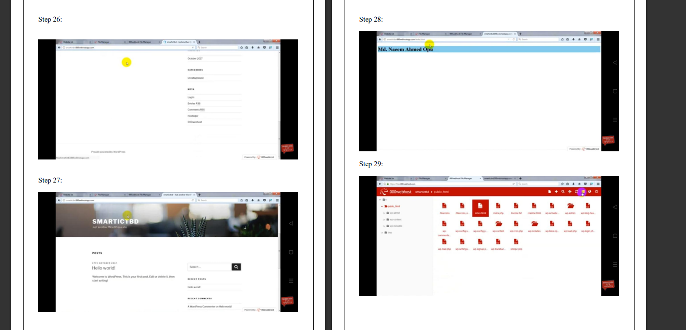

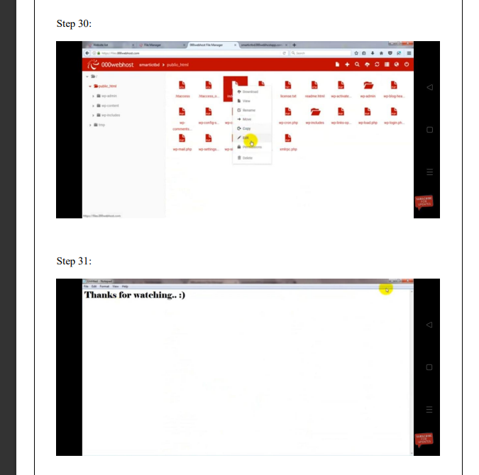

**Practical No 8: Upload any demo video on YouTube.**

**Step 1 : Search on google youtube.com , click on 1st website and sign in your account after that we can see youtube is open**

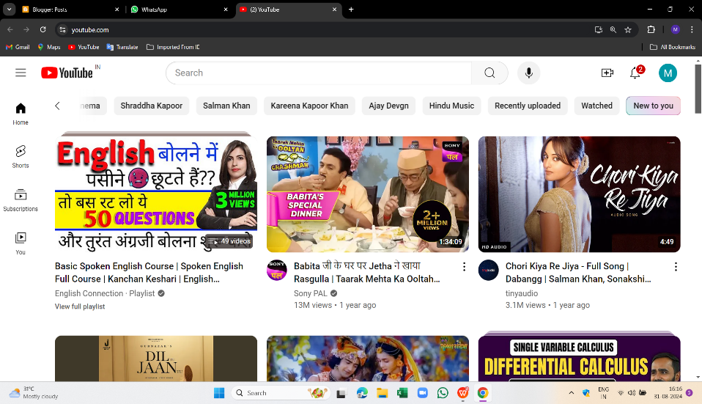

**Step 2: Go to your profile,select youtube studio**

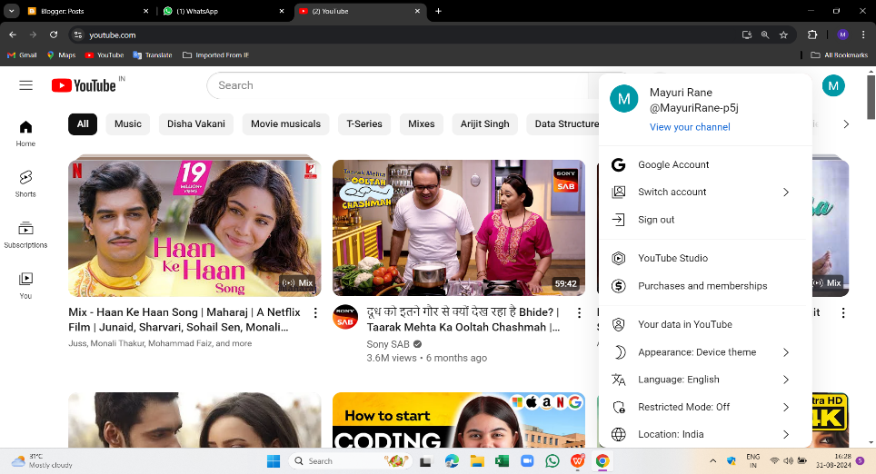

**Step3: Click on upload videos that we can download on google**

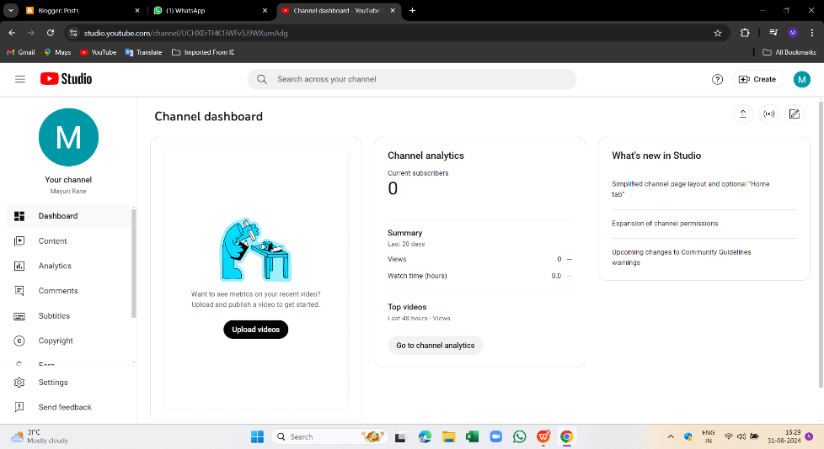

**Step 4 :Click on select files**

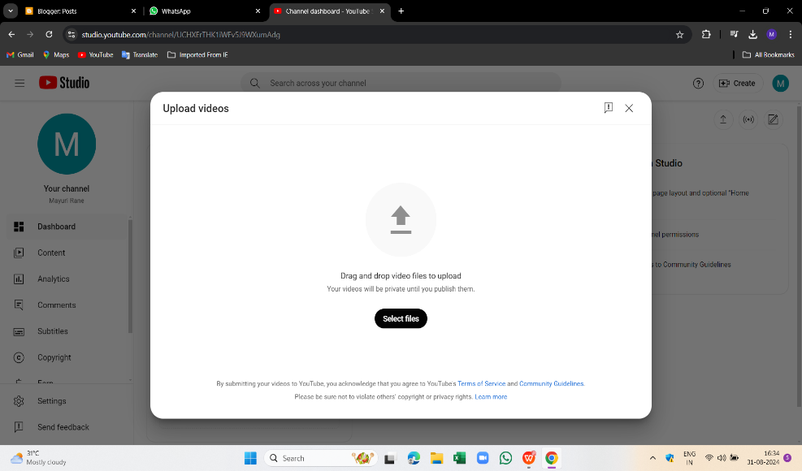

**Step 5 : Click next**

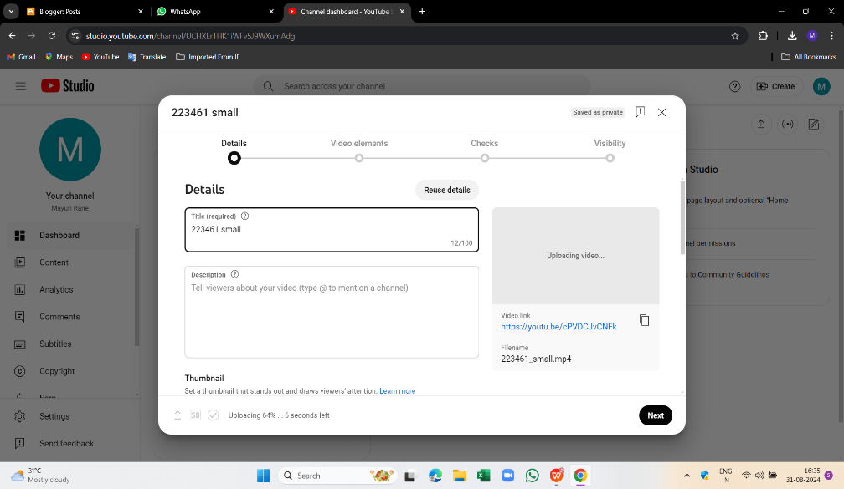

**Step 6 :click on next**

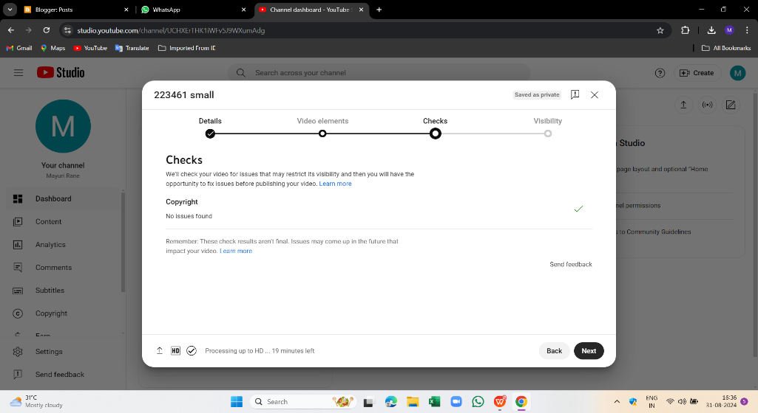

**Step 7: Save the video and publish it privately ,now the video is uploaded**

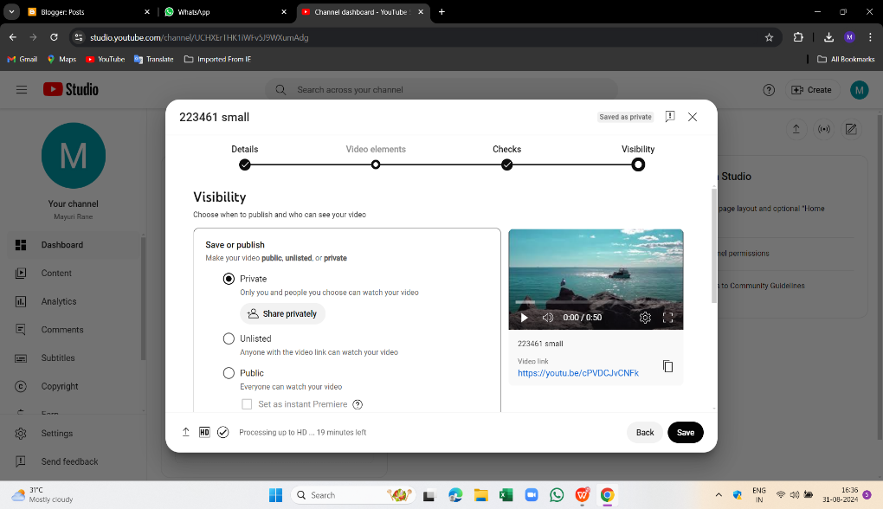

**Practical No 9: Create and develop your blog**

**Step 1: Search on google – Blogger.com**

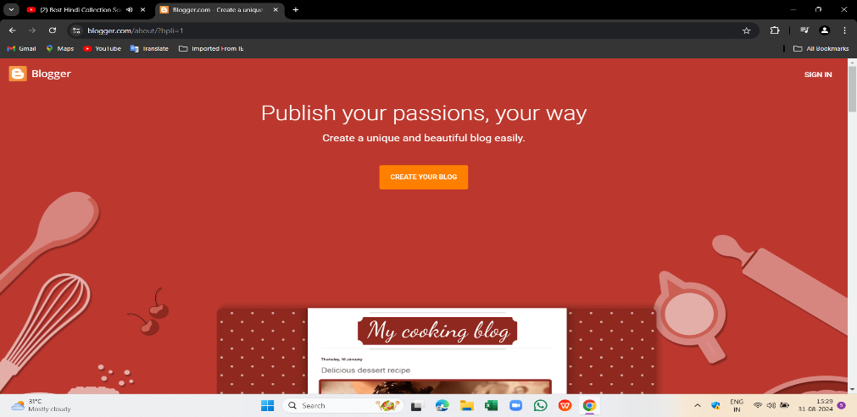

**Step 2 : After that ,sign in and press next.**

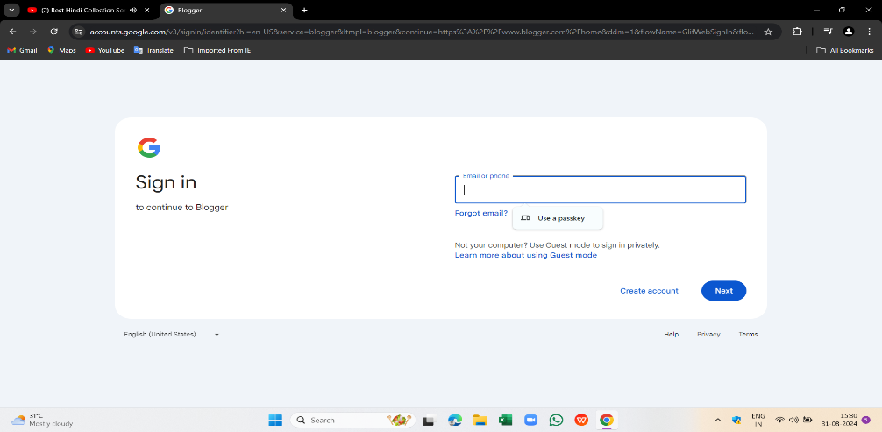

**Step 2: We can see the blogger page open ,next click on new post**

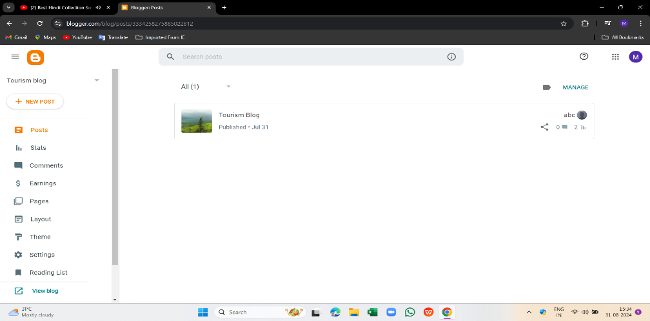

**Step 4:The new post is open**

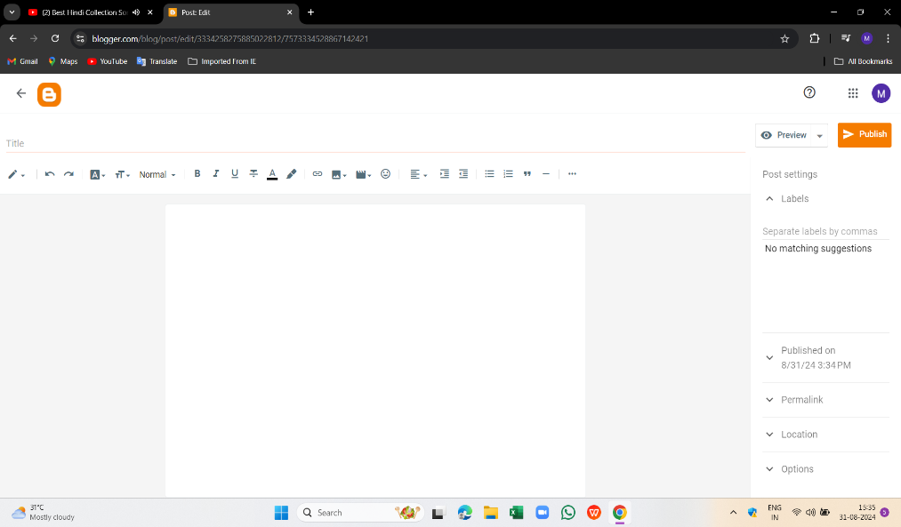

**Step 5: Here we create our blog and give it title**

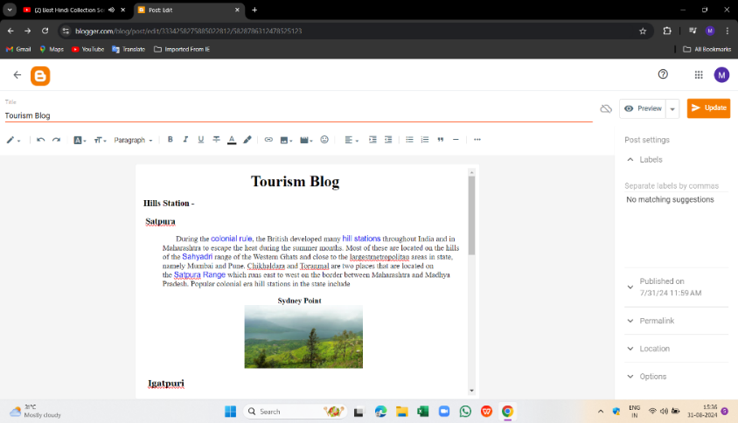

**Step 6: Click on publish and select confirm**

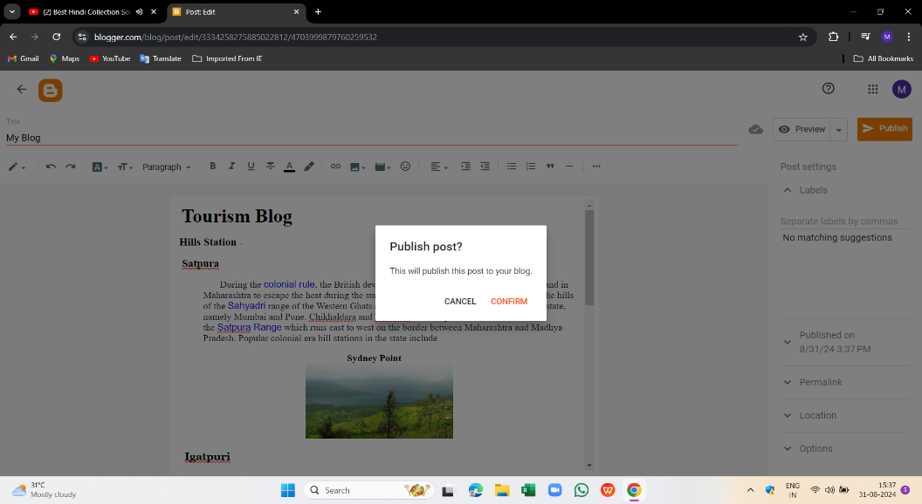

**Step 7: Here we can see our blog is published**.

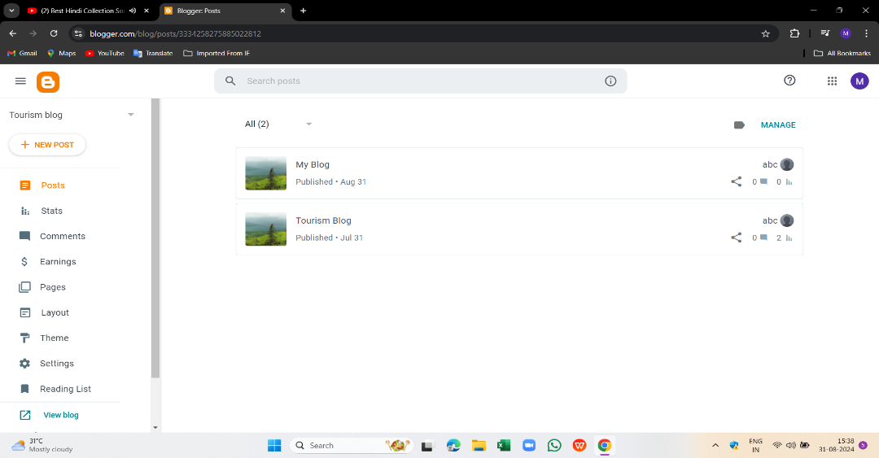

Prac 10: : Demonstrate E-Mail Functions

Html:

<!DOCTYPE html>

<html lang="en">

<head>

 <meta charset="UTF-8">

 <meta name="viewport" content="width=device-width, initial-scale=1.0">

 <title>Email Form</title>

 <link rel="stylesheet" href="styles.css">

</head>

<body>

 <div class="container">

 <h1>Email Form</h1>

 <form id="emailForm" onsubmit="return validateEmail()">

 <label for="email">Enter your email:</label>

 <input type="email" id="email" name="email"

placeholder="example@domain.com" required>

 <button type="submit">Submit</button>

 <p id="message"></p>

 </form>

 </div>

 <script src="script.js"></script>

</body>

</html>

Css:

*{

    margin: 0;

    padding: 0;

    box-sizing: border-box;

   }

   body {

    font-family: Arial, sans-serif;

    background-color: #f0f0f0;

    display: flex;

    justify-content: center;

    align-items: center;

   Page No.

    height: 100vh;

   }

   .container {

    background-color: #fff;

    padding: 20px;

    border-radius: 8px;

    box-shadow: 0 4px 8px rgba(0, 0, 0, 0.1);

    text-align: center;

    width: 300px;

   }

Javascript:

function validateEmail() {

    const emailField = document.getElementById("email");

    const message = document.getElementById("message");

    const email = emailField.value;

    const emailPattern = /^[^\s@]+@[^\s@]+\.[^\s@]+$/;

    if (emailPattern.test(email)) {

    message.textContent = "Valid email address!";

    message.style.color = "green";

    return true; // Form will be submitted

    } else {

    message.textContent = "Invalid email address. Please try again.";

    message.style.color = "red";

    return false; // Prevent form submission

    }

   }